AT3 Logbook

Andrew Tran | William Clarke College

Development Diary

Software Engineering 2025

**Contents**

Date: 04/02/2025 – Starting the project

**Progress**

|  |  |
| --- | --- |
| Achievements | Stumbling Blocks |
| * Chosen project idea * Started writing client scenario (1.1) * Created AT3 folder for project duration * Created logbook file | * Deciding the advanced features for the application and how they would practically look in the app |

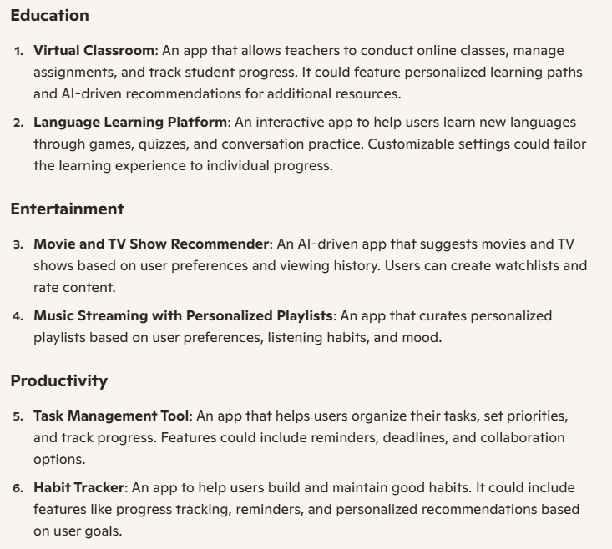

*Figure 1.0: Screenshot of CoPilot’s list of app ideas to use for this project*

**Evaluation**

To choose an idea for my application, I brainstormed useful applications that I already had installed on my phone, asked AI tools to generate a list of application ideas (figure 1.0), and consulted with class peers. Eventually, I arrived on the idea of a habit tracking app which personally resonated with me as I viewed building healthy habits as an important skill in one’s life.

After deciding my idea, I considered factors like my target audience, the application’s purpose, and real-life examples of how the application could be used. This all informed my writing process for the client scenario (1.1). The most difficult part of writing the client scenario was identifying which advanced features to include in the application and practically envisioning their individual functionalities. Overall, I was satisfied with the start I had made to my project and felt prepared to continue the task in future.

Date: 09/02/2025 – Environmental Specifications / Section 1 work

**Progress**

|  |  |
| --- | --- |
| Achievements | Stumbling Blocks |
| * Filled out environmental specifications table * Created objectives list | * Identifying how to fill out both tables and what information to include * Structuring these sections of the documentation |

**Evaluation**

Although, the environmental specifications table was initially more confusing to me, the objective list took longer to fill out. This is because I aimed to write out around 10-12 functional and non-functional objectives which took considerable time to write. To assist my approach in writing the environmental specifications I went back and watched a previous Teams call to look at environmental specifications table my teacher had created. After transferring this to my document, I was still confused on this table should be filled out. From consulting with my teacher, I recorded the different hardware and software specifications of my laptop and the network specifications of the network I was currently connected to. I then filled the ‘image’ column with relevant photos to finish off the table.

Date: 14/02/25 – Performance criteria / section 1 work

**Progress**

|  |  |
| --- | --- |
| Achievements | Stumbling Blocks |
| * Wrote and finished performance criteria * Created Gantt Chart | * Structuring performance criteria |

**Evaluation**

Approaching the performance criteria, I had an idea of what types of structuring were possible (from environmental specs and objectives list) for a question like the performance criteria. However, it still proved to be difficult determining a successful structure that would allow me to clearly identify criteria and sufficiently describe them. Nonetheless, colour coordination allowed for me to easily divide the criteria categories and create a table for the task. After finishing this task, I created a gantt chart template on Microsoft Excel. This task was considerably easier for me as I had created gantt charts in previous tasks and had received positive feedback for my design.

Date: 15/02/25 - IPO chart / section 1 work

**Progress**

|  |  |
| --- | --- |
| Achievements | Stumbling Blocks |
| * Finalised IPO chart | * Describing in detail |

**Evaluation**

After feedback from my teacher, I went back on my previous iteration of my IPO chart and wrote more detailed descriptions for the process column. This required me to think through a practical representation of the application’s data handling to identify any other inputs/outputs and how I can clearly convey the process I’m trying to describe. At this stage I had completed all of section 1 and was feeling confident to continue working through the rest of the project.

Date: 20/02/25 – Creating the coding environment

**Progress**

|  |  |
| --- | --- |
| Achievements | Stumbling Blocks |
| * Created version control codebase on VS Code * Synced files to GitHub Repository | * Linking repo to vs code environment |

**Evaluation**

Initially, I tried to create the codebase by creating a repository on GitHub first and then syncing this with an environment in VS Code. This did not end up working as I was not informed on what instructions I could follow to link these two environments and tried to sync these purely from past experience. After failing the first time, I deleted the old repo and VS Code file and started fresh. This time, I searched for and followed a tutorial on Youtube to link the two environments. This worked significantly better as the Youtube tutorial had proof that it could reach the finished result and had a more informed understanding compared to my past experience of using GitHub and VS Code last year.

**Helpful Resources**

* <https://www.youtube.com/watch?v=i_23KUAEtUM> | Using Git with Visual Studio Code (Official Beginner Tutorial) (7min)

Date: 24/02/25 – Section 2 kick-off

**Progress**

|  |  |
| --- | --- |
| Achievements | Stumbling Blocks |
| * Conducted research in accordance with section 2.1 of the task * Started designing data flow diagrams | * Finding relevant sources * Writing research findings in a formal manner |

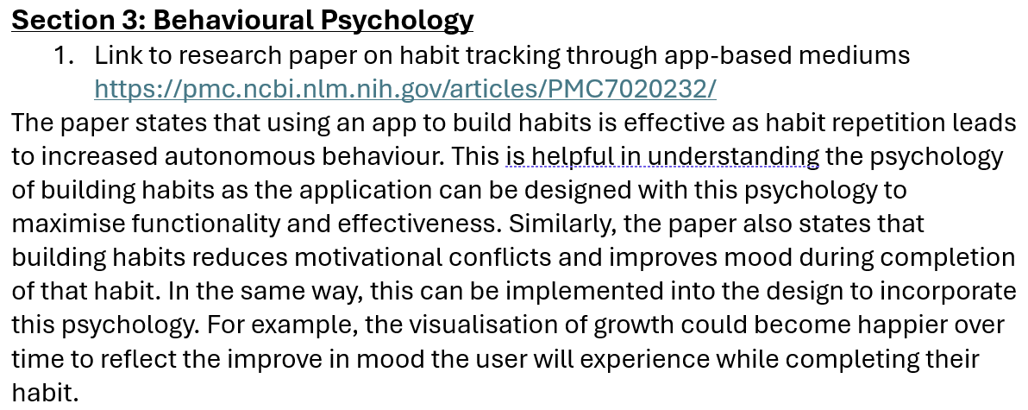

*Figure 2.0: Section 3: Behaviour Psychology of my research (2.1) which may be removed in project’s future*

**Evaluation**

To research information around a habit tracking app, as stated in 2.1, I split up my research categories into Similar Applications, User Research, and Behavioural Psychology. This made it easier to structure the research I conducted and target specific areas of the task. Reflecting on the research I did, I could have spent less time filling out this section of the documentation however felt it was necessary to present my research as authentic and unique. I am still quite unsure on the relevance of Section 3: Behavioural Psychology however did find fascinating information around habit building. I may choose to remove this section from my research and submit with only two sections. Although this finishes with less work, it may remove unwanted clutter and irrelevant information.

Date: 26/02/25 – Data flow diagrams / section 2 work

**Progress**

|  |  |
| --- | --- |
| Achievements | Stumbling Blocks |
| * Designed all 3 diagrams * Added logic and clarity to my advanced features | * Writing explanatory paragraphs for these diagrams |

**Evaluation**

Creating the diagrams, initially required me to practically think through how my advanced features would work. This helped me identify the logic behind them and hence derive the movement of data in these features. When designing these diagrams, I tried to incorporate many different process to record their movement of data and have a more comprehensive diagram. After pasting my diagrams in my documentation scaffold, I discovered that these must be accompanied by an explanatory paragraph. Although, writing these paragraphs were not hard, as I had a detailed understanding of how my chosen advanced features worked, it took a long amount of time and required me to work for longer than I expected. By the end of it, I was tired but also happy that the work was completed.

Date: 27/02/25 – Storyboards / section 2 work

**Progress**

|  |  |
| --- | --- |
| Achievements | Stumbling Blocks |
| * Finished three storyboards * Started work on wireframes | * Establishing the main differences between storyboards and wireframes * Finding the best software to make these designs on |

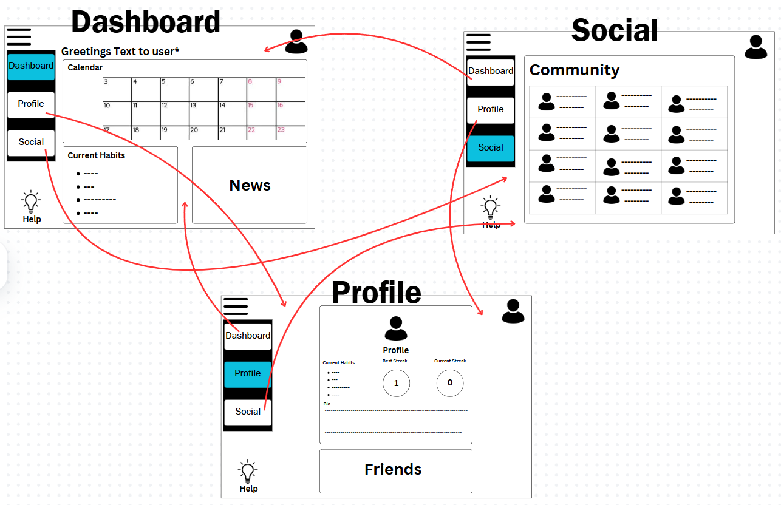

*Figure 2.1: Design of storyboards for section 2.4 including navigational arrows (designed in Canva)*

**Evaluation**

When creating the storyboards, I focused on creating a minimalist design and clearly establishing how the user navigates between pages. A dropdown menu was the most appropriate option as this provides clear navigation without obscuring the user’s screen. I also aimed to incorporate my advanced features in the storyboard which included the gamification aspects (in-game shop, streak counter) and chatbot functions (help icon).

The creation of my storyboards gave me a base template to use for my wireframe diagrams. I copied the same design over but focused on explaining the design and functionality of the webpages instead. This allowed me to describe the features of the application’s screens and expand on how I imagined the app to function. As of now, I have not finished creating my wireframe diagrams but feel equipped with a good understanding of how to complete them tomorrow.

**Helpful Resources**

* <https://curriculum.nsw.edu.au/learning-areas/tas/software-engineering-11-12-2022/overview#software-engineering-course-specifications-software_engineering_11_12_2022> | Software Engineering Course Specifications (Page 9 Storyboards)

Date: 28/02/2025 – Wireframes / section 2 work

**Progress**

|  |  |
| --- | --- |
| Achievements | Stumbling Blocks |
| * Finished wireframes | * Providing the same level of explanation from when I was last working on this task |

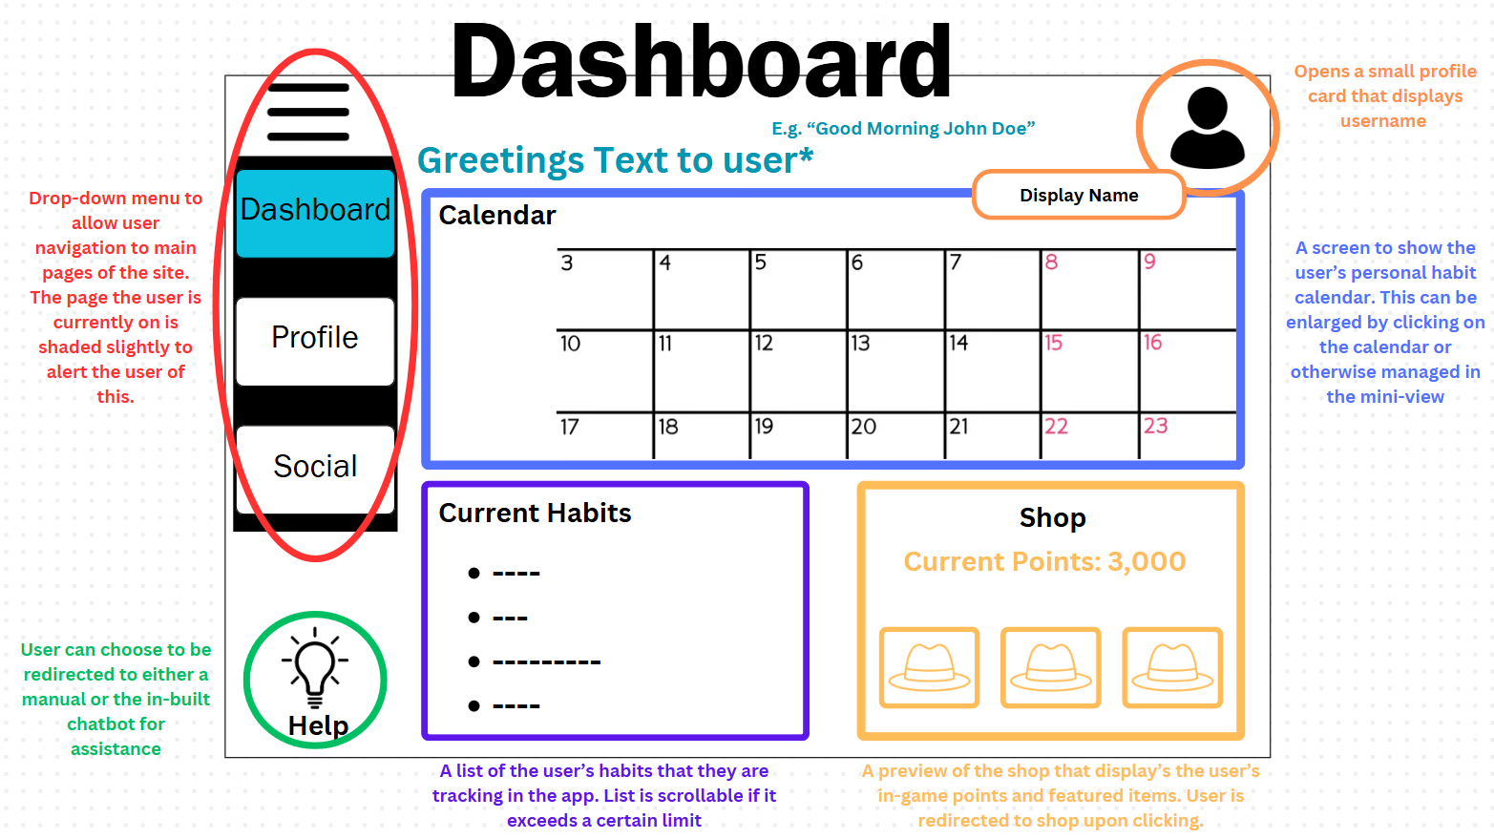

*Figure 2.2: Design for wireframe diagrams using colour coding to explain different UI elements*

**Evaluation**

I was picking up from where I left off with the wireframe diagrams meaning I already had a good understanding of how I was going to finish the designs. I decided to explain different layout elements through colour-coding a section and accompanying it with appropriately coloured text. The next task is to write pseudocode algorithms which is vastly different from the previous two activities however, I do feel that thinking through these activities has helped me understand the functionality of my app better and in-turn will help me with writing pseudocode.

Date: 4/03/2025 – New wireframes

**Progress**

|  |  |
| --- | --- |
| Achievements | Stumbling Blocks |
| * Redid wireframe diagrams using Miro * Added more application screens to my wireframe diagrams | * Deciding the best application to design wireframe diagrams |

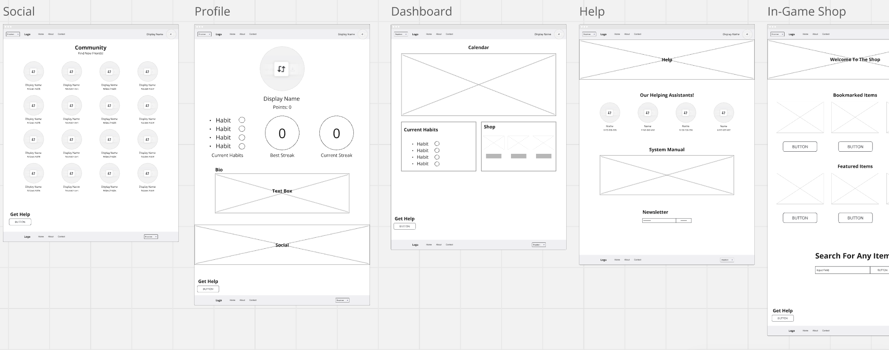

*Figure 2.3: Reworked wireframe designs using Miro*

**Evaluation**

After teacher feedback on section 2 of my project, my wireframes and pseudocode were identified as my weakest areas. I decided to revisit these sections and improve them. I started with the wireframes, redesigning these using Miro after discussion with peers. Miro provided a wireframe template for me which had all wireframe elements already implemented on the page. I was able to move these elements around to restore the previous design I had created on Canva. Using Miro made slight changes to the design of my wireframe, substituting detailed images for placeholders and other similar changes. I also ended up adding more wireframe screens for my application than the three screens I had for the storyboard which allowed me to plan out more of my application’s screens. I will later have to add these others screens to the storyboard to demonstrate how the user navigates between the different pages. Next task will be to finish the pseudocode algorithms.

Date: 9/03/25 – Additional research

**Progress**

|  |  |
| --- | --- |
| Achievements | Stumbling Blocks |
| * Conducted more research for 2.1 research | * Finding suitable implementation tutorials |

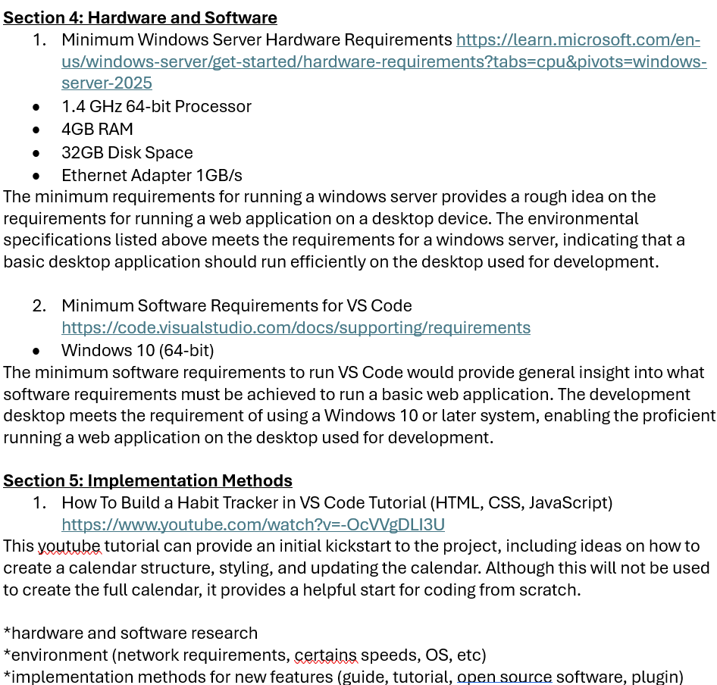

*Figure 2.4: Added research to section 2.1 research*

**Evaluation**

I went back on my research to add more information about the hardware, software, and network of the application. This included finding resources that listed suitable hardware / software requirements for a basic application. I then summarised this information and explained why this benefitted the research for my project. I also included system implementation methods for the project which I could come back to during the start of the project’s development. This will be an ongoing list of helpful resources that I find during research which I can use to assist in the project’s development.

Date: 16/03/25 – New storyboards

**Progress**

|  |  |
| --- | --- |
| Achievements | Stumbling Blocks |
| * Reworked the storyboards to include more UI elements | * Collating all the design elements to create four new storyboards |

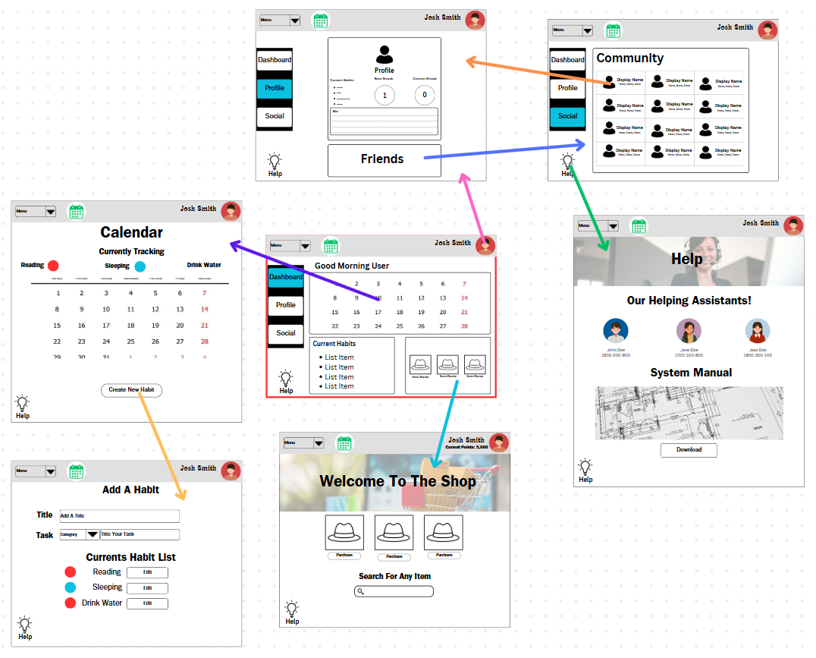

*Figure 2.5: Storyboards with more UI elements*

**Evaluation**

Creating the storyboards was time consuming as I originally only had three storyboards but decided to create four more to match all seven of my wireframe diagrams. I created the storyboards on Canva, trying my best to mirror the design of my wireframes but with intentional UI elements such as images, colours, headers, etc. The narrative was able to stay the same as the logic didn’t change, only the designs. Overall, I am happy with how my storyboards turned out and there accuracy in mirroring my wireframes.

Date: 19/03/25 – Pseudocode algorithms

**Progress**

|  |  |
| --- | --- |
| Achievements | Stumbling Blocks |
| * Finished five pseudocode algorithms with comments and explanations | * Abiding by proper pseudocode syntax and logic |

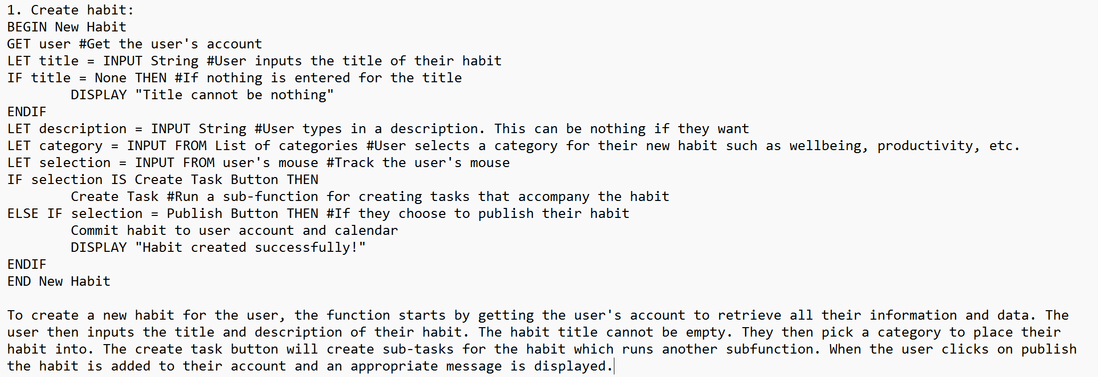

*Figure 2.6: A pseudocode algorithm with comments and explanations*

**Evaluation**

When writing my pseudocode algorithms, I researched the proper syntax and logic as specified by the course specifications. This refreshed my memory of writing pseudocode algorithms for my previous projects. After doing this, I felt equipped to write all five algorithms which took around an hour total to work out the logic and record on the page. I interestingly found that most of my algorithms used IF loops and took many user inputs. I will keep this is in mind when programming my application but also may find that the logic in the pseudocode algorithms needs to be edited to fit the application.

Date: 31/03/25 – HTML and CSS of App

**Progress**

|  |  |
| --- | --- |
| Achievements | Stumbling Blocks |
| * Files transferred from Ed to VS Code * HTML created for calendar page * CSS created for calendar page | * Linking sheets together * Having the server start on the calendar |

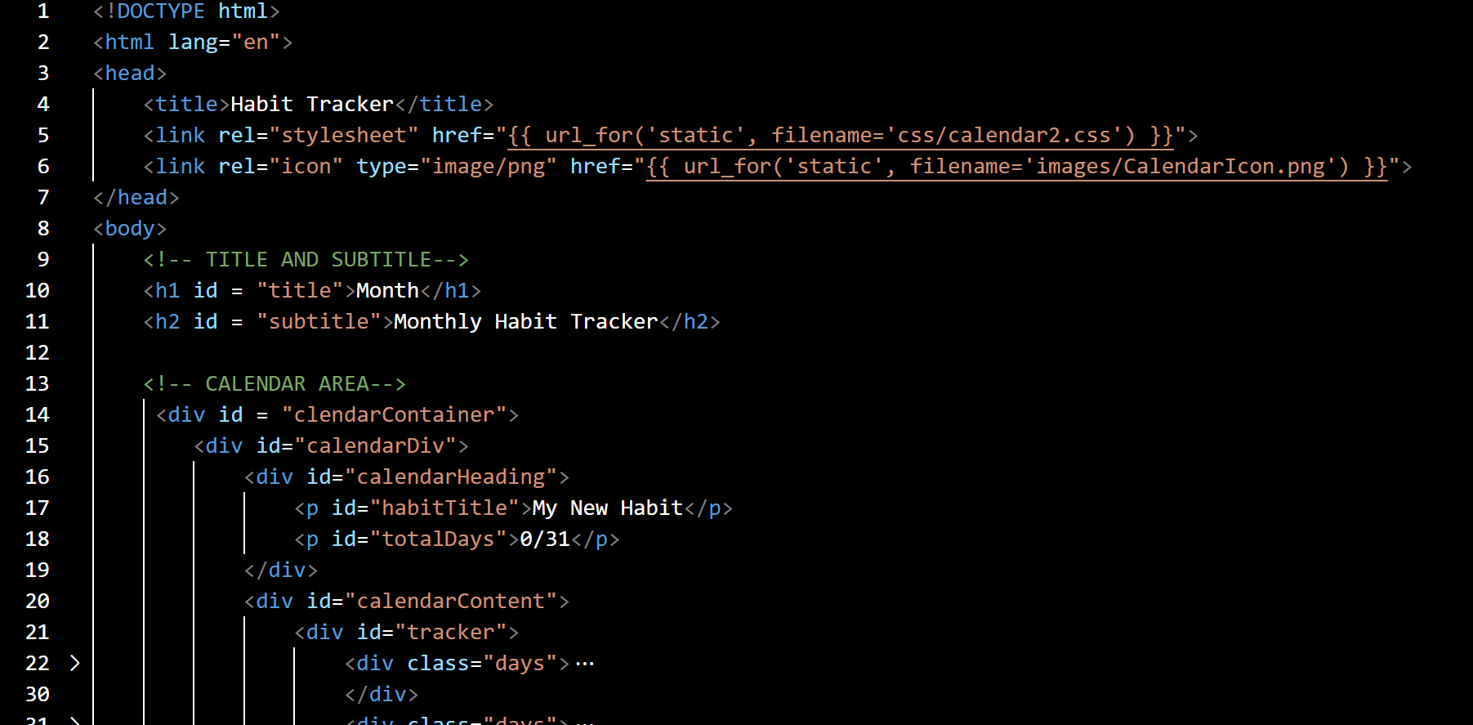

*Figure 3.0: Screenshot of calendar.html showing the basic webpage setup*

**Evaluation**

By downloading the files from Ed Stem I was able to get an initial backbone for my project. I followed one of the tutorials linked in my research to create the html file for the calendar page. To test if this was working, I changed it so the server would start by showing the calendar file instead of Ed Stem’s dashboard. After checking that the calendar appeared as expected, I followed the tutorial to create the CSS style sheet for the calendar. However, I did not feel the css from the tutorial was fitting for my project so I fed my HTML file into ChatGPT and asked it to generate a stylesheet that fits a professional habit tracking app. The code from the AI generated style sheet was not too dissimilar from the style sheet in the tutorial apart from pixel values and colour choices. After using AI tools, I learnt what styles look better for a professional feel and understood the creative freedom CSS gives the developer. My next approach will be to continue following the tutorial to create the functionality through JavaScript.

Date: 13/05/25 – JavaScript and App Functionality

**Progress**

|  |  |
| --- | --- |
| Achievements | Stumbling Blocks |
| * JavaScript created for calendar page | * Following the tutorial and receiving the same result |

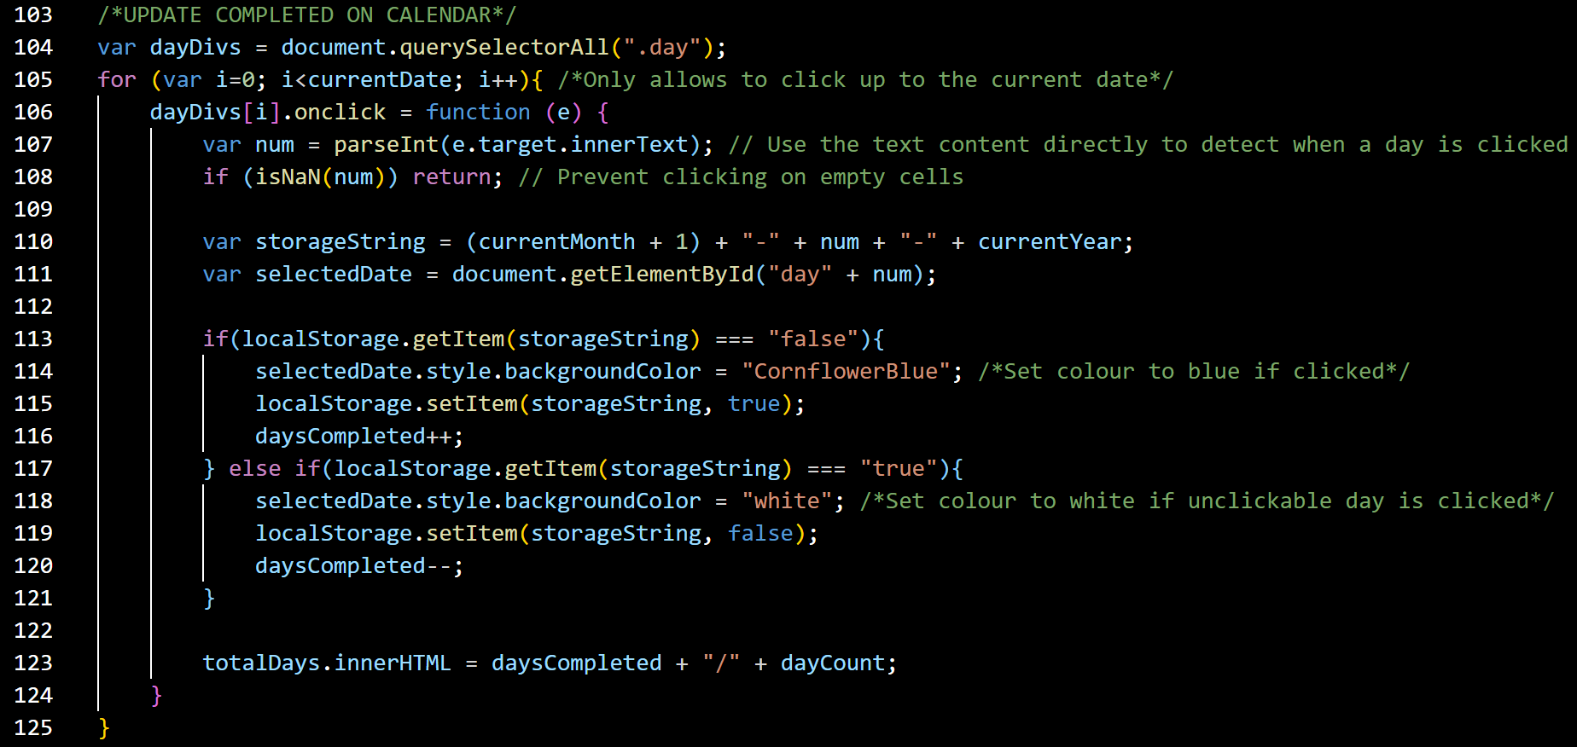

*Figure 3.1: Screenshot from calendar.js showing the code to mark off a completed day*

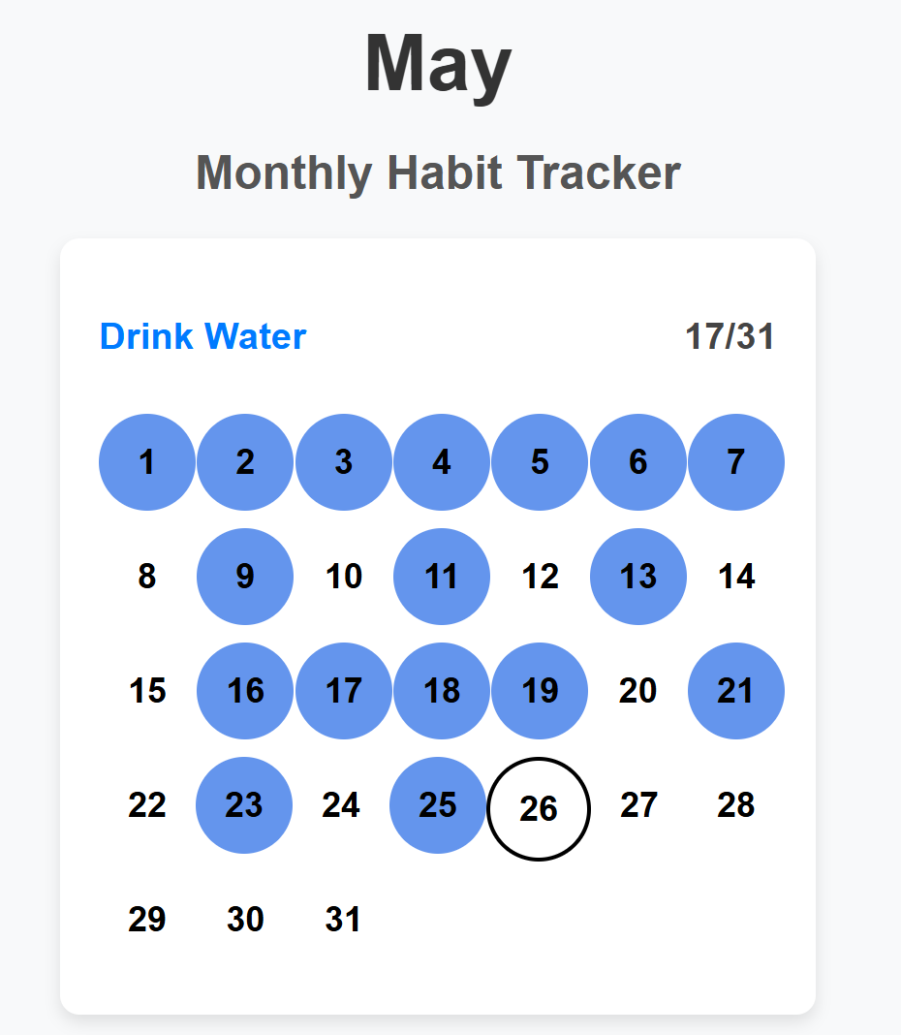

*Figure 3.2: Current state of the calendar page with completed days highlighted in blue and the current day outlined in black.*

**Evaluation**

I continued to follow the video tutorial series that taught me how to set up my HTML and CSS files. While following the tutorial was fine, when I checked the progress of the app, the page would not function as intended by the video. To fix this I would go through the code and comments and change the functionality to be better suited to my browser. Most of the problems I received came from the tutorial’s use of local storage, which I was unable to see in the Chrome browser. This meant the user’s progress wasn’t updating properly when clicked on. I fixed this by detecting progress through the text of a day class rather than the local storage used in the youtube tutorial. This meant it would essentially detect if a day was marked by using the text it held, such as “1”, “24”, etc, and seeing the current state of that day. It would then update its state accordingly. Continuing the calendar page, I plan to add days onto the calendar that displays Monday to Sunday and add a functionality to track multiple habits, as the app is intended to do. Before I start those however, I will progress by building the rest of the other webpages in a basic form to confirm navigation works.

Date: 27/05/25 – Adding a nav bar

**Progress**

|  |  |
| --- | --- |
| Achievements | Stumbling Blocks |
| * Added a navigation bar and dropdown menu to the app | * Styling the webpage and aligning the text to the left |

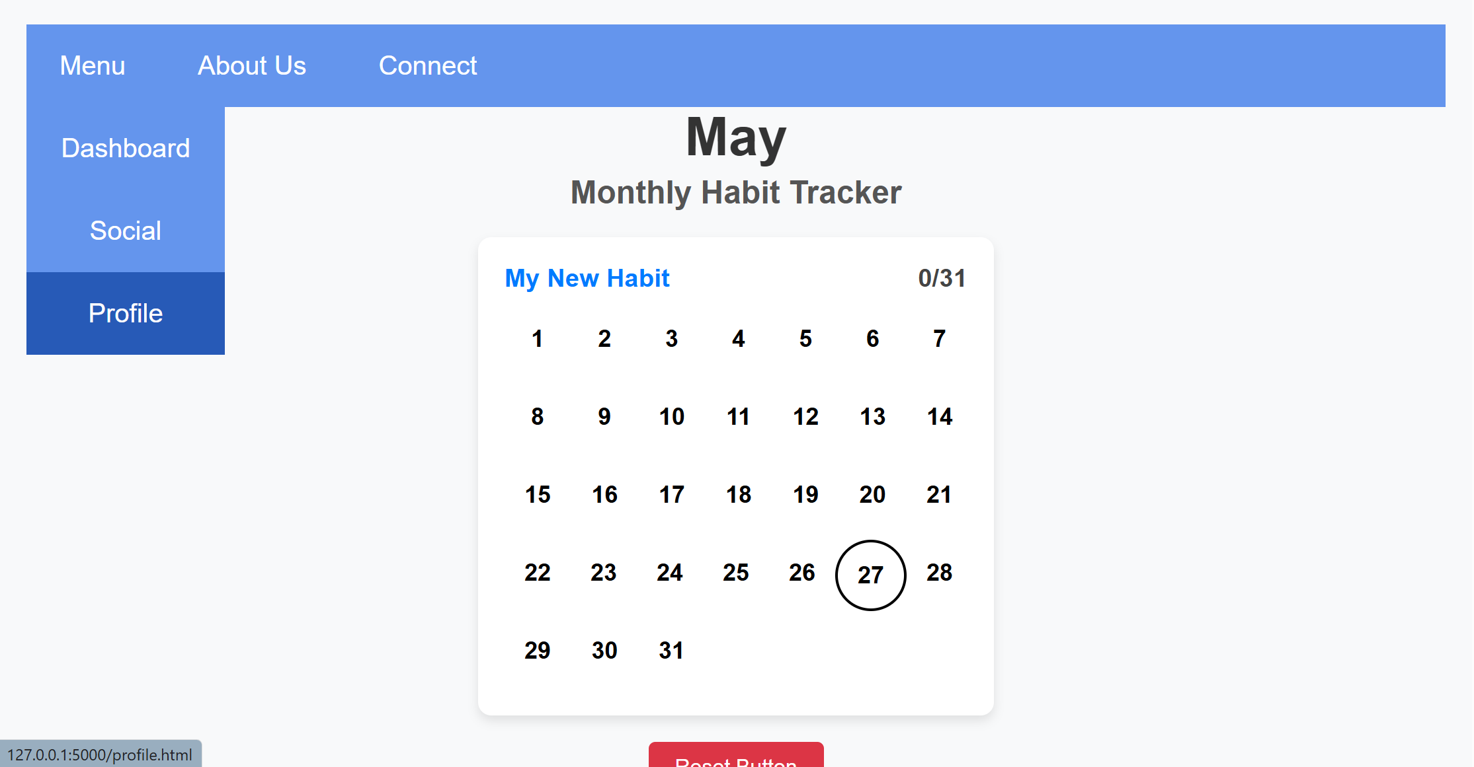

*Figure 3.3: Nav bar with dropdown menu added onto the calendar page*

**Evaluation**

Creating the nav bar for the webpage was quite simple as I could follow a simple youtube tutorial (<https://www.youtube.com/watch?v=dmFC1e_CUAQ>) for the code. This only required html and css making it easy to understand. Further, I found that I could go through the tutorial code and tweak it to be relevant to how I wanted the app to look and feel, changing the colours, and hierarchy of buttons. The most difficult challenge was figuring out how to align the text of the nav bar to have the buttons start on the left rather than in the centre. I eventually found the ‘text-align’ attribute and set this left, achieving the desired look. To continue I plan to add the functionality of the other webpages to set up a very basic app feel.

Date: 10/6/25 – Login System

**Progress**

|  |  |
| --- | --- |
| Achievements | Stumbling Blocks |
| * Created a login system for users * Server routes pass data for user login | * Coding the server routes to work as expected |

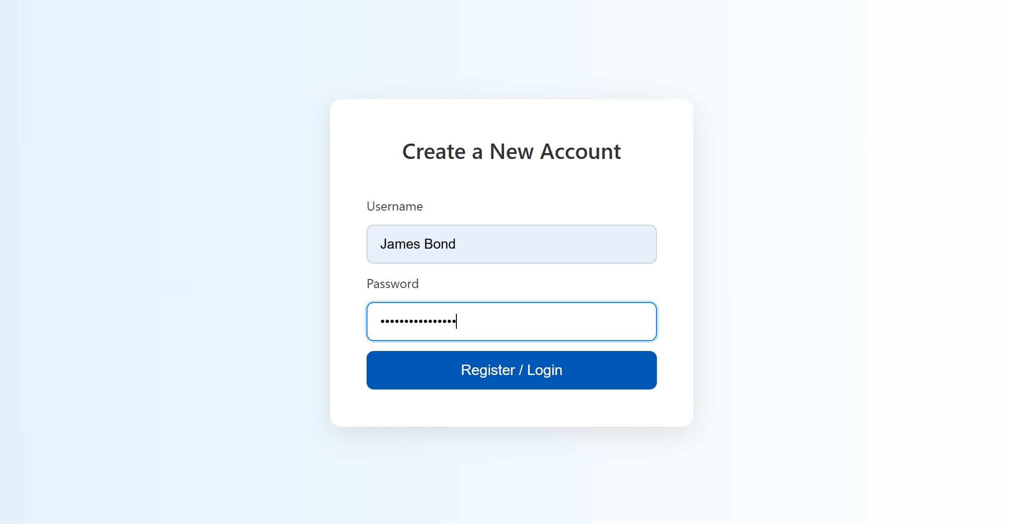

*Figure 3.4: User login page*

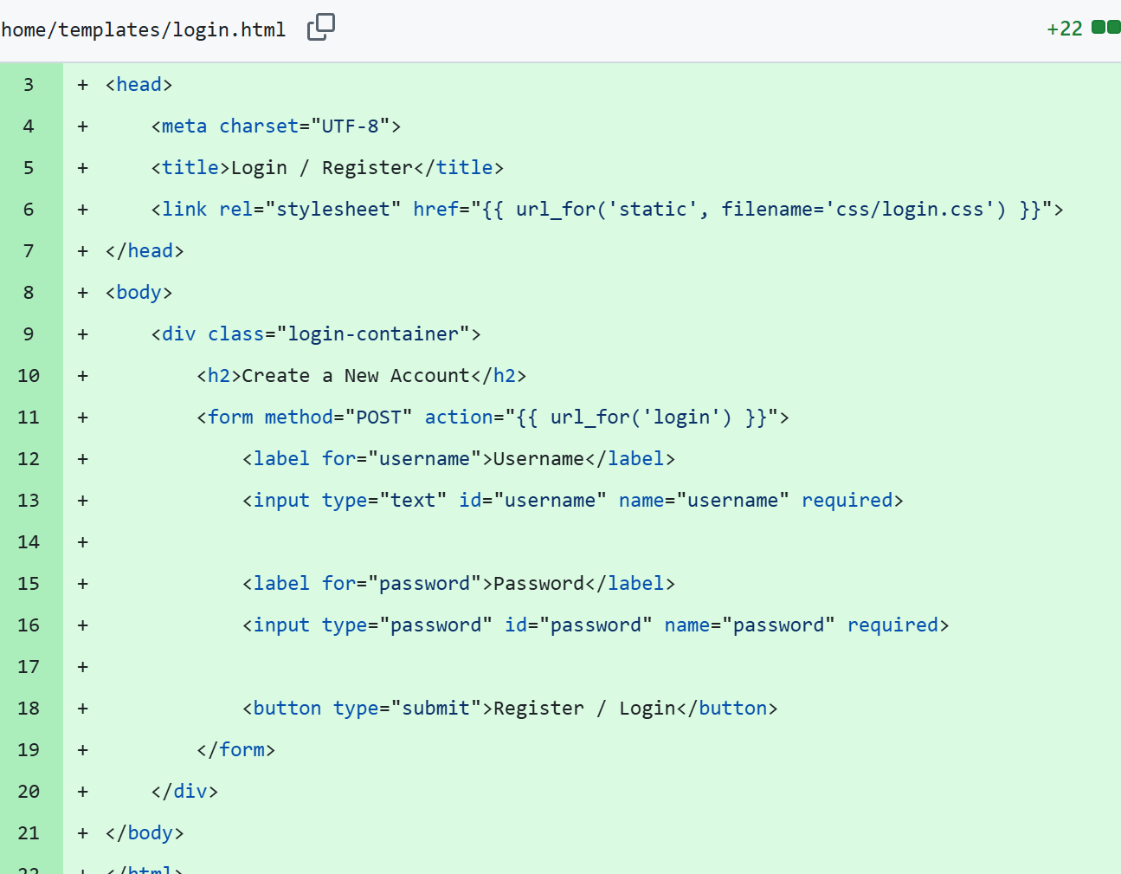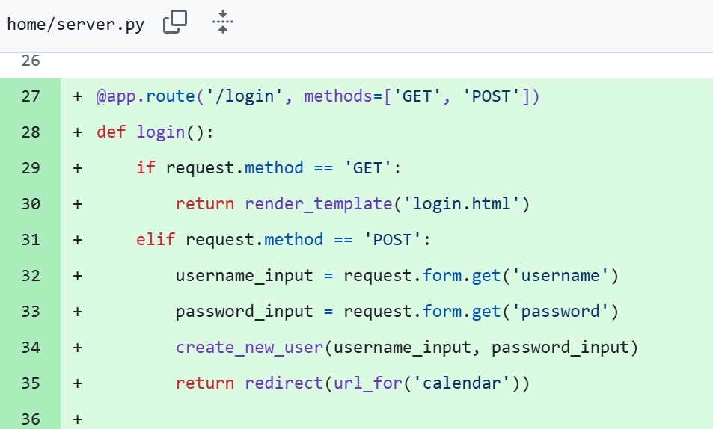

**Evaluation**

I created the login system by following the tutorials on Ed Stem and applying it to my app in VS Code. This worked well as the Ed Stem activity inputted the data through text boxes which allowed me to easily translated it to my app as I also intended to use text boxes and a submit button to capture the user’s login details. I followed a tutorial for setting up the HTML and CSS of the login page (<https://www.w3schools.com/howto/howto_css_login_form.asp>) however, I edited it to be relevant to my app and use the colours and styling that I wanted. This provided me with some confidence as I will have to do more data passing through servers later in the project (for habit tracking, etc), so having this working was a good start. To continue I’d like to try and store data for habits specific to a user and logs specific to a habit. This may take longer though as this is more complicated and won’t use only text boxes for data capture.

Date: 16/6/25 – Session Management and Habit Creation System

**Progress**

|  |  |
| --- | --- |
| Achievements | Stumbling Blocks |
| * Habit creation system implemented * User account system created with session management * Habits are unique depending on which user created them * Log in, log out, and sign up system created * Dynamic profile page | * Coding the user’s id into the session * Displaying only habits that are for the logged in user |

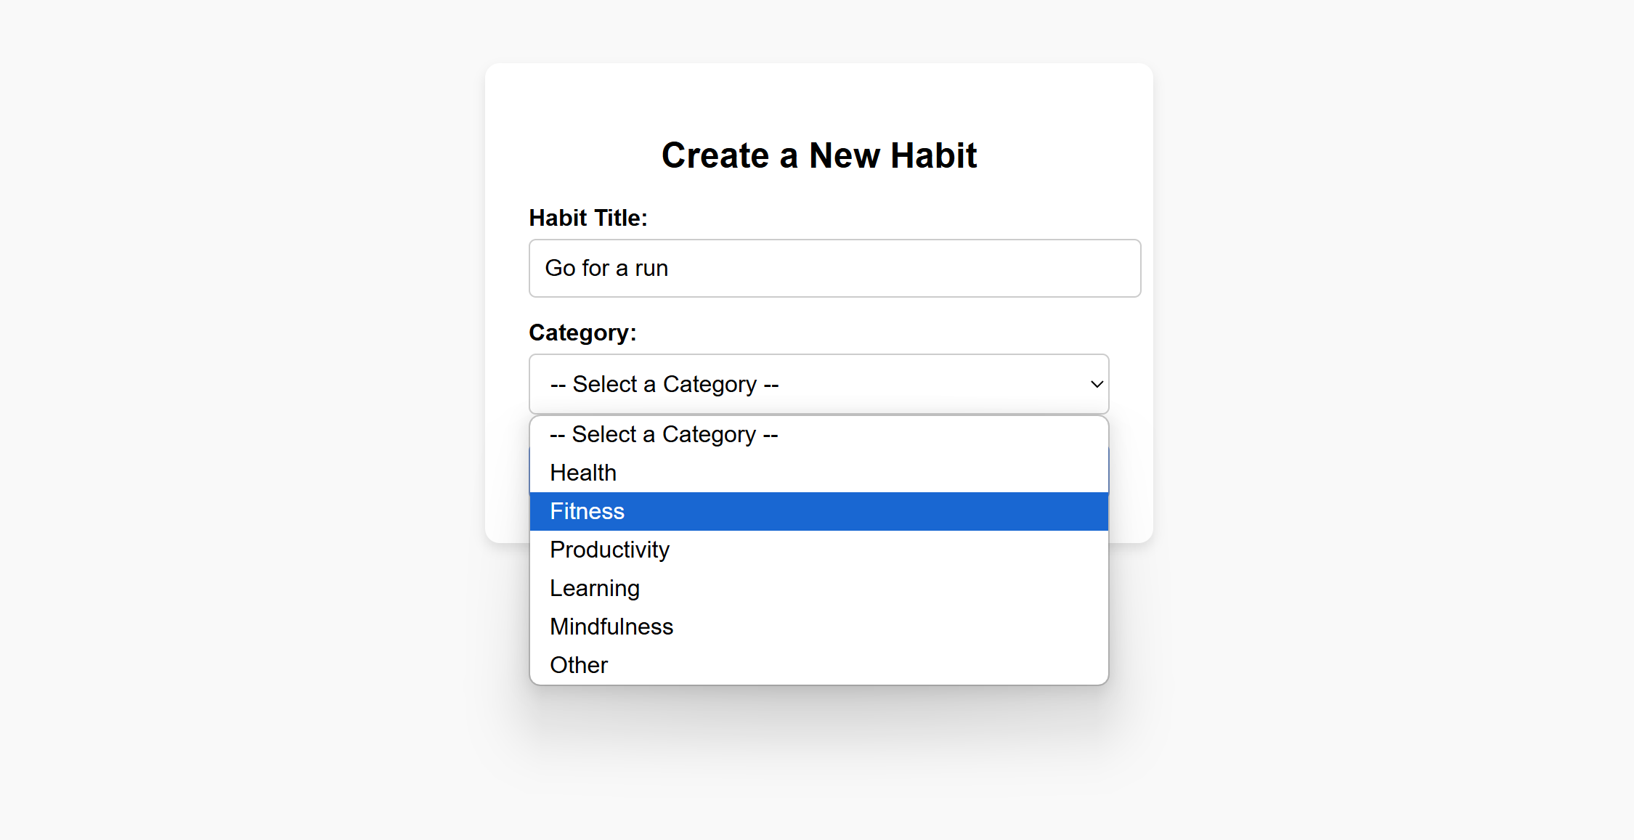

*Figure 3.5: Page for creating habit with custom title input and category selection from dropdown list*

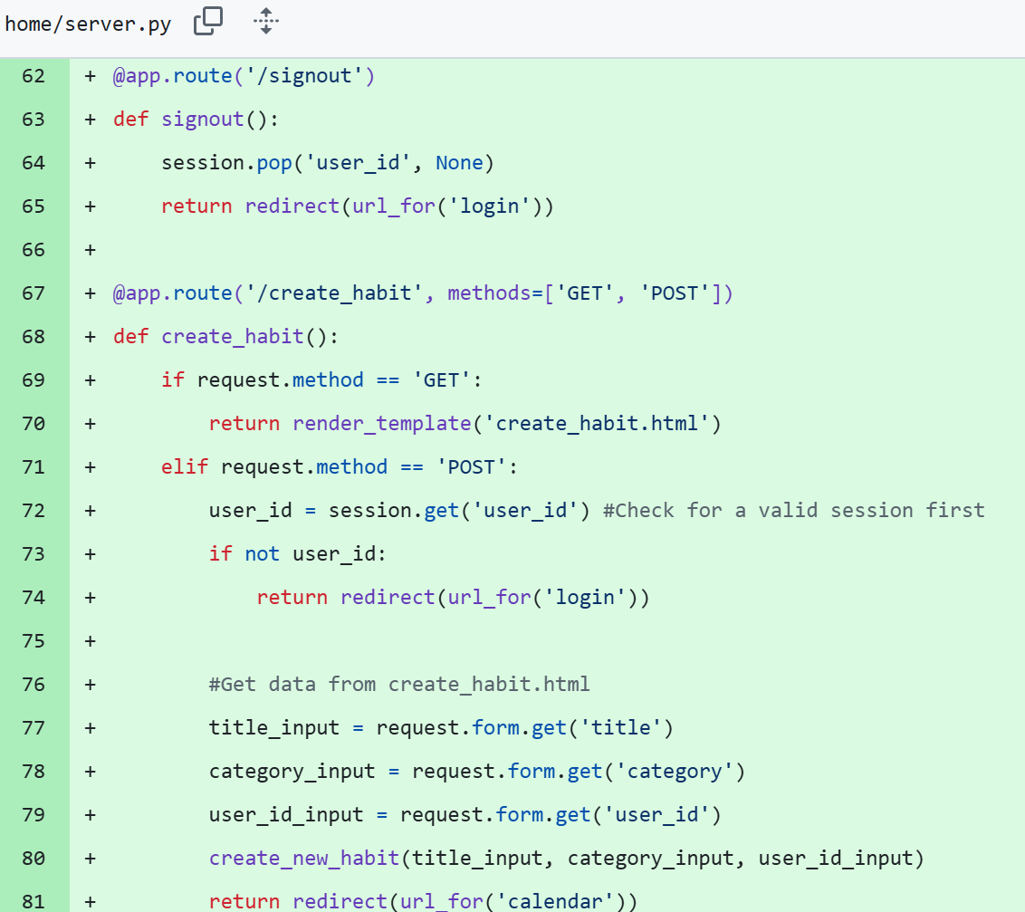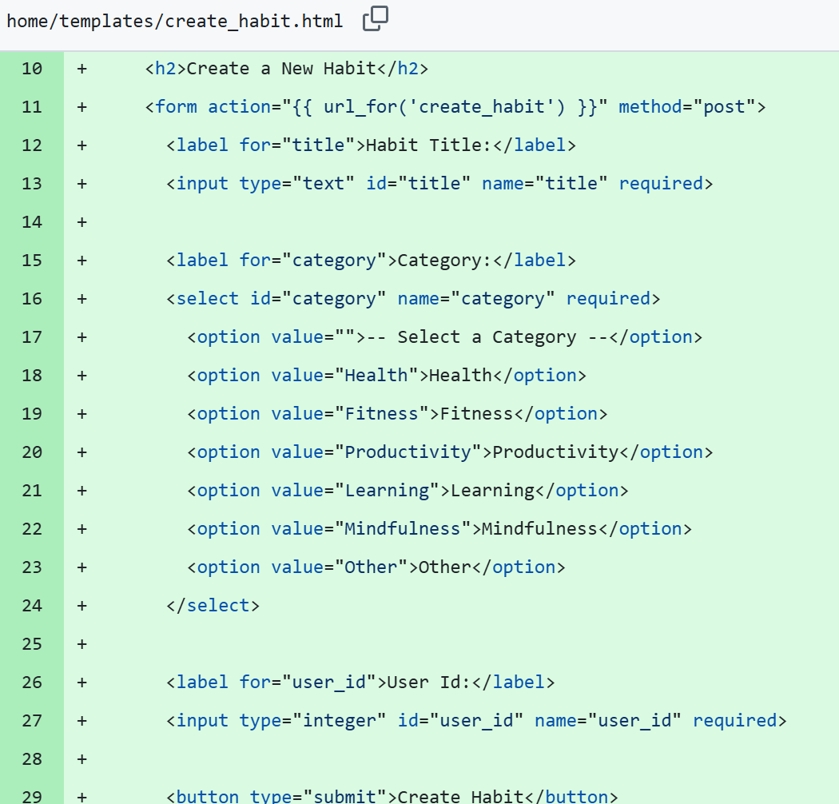

**Evaluation**

For the habit creation system, I quickly brainstormed to identify that every habit needed to have a title and category. After further research, I also found that to make a habit unique to a user’s account, I needed to link user_id as a foreign key to the habits table. I was able to do this from researching online about foreign key relationships in SQL alchemy tables and applying this to my own database (<https://stackoverflow.com/questions/18807322/sqlalchemy-foreign-key-relationship-attributes>). I followed this tutorial (<https://www.youtube.com/watch?v=xX1pQAJmseE>) to program the dropdown menu.

To make the app a unique experience dependent on the logged in user, I stored the user’s ID in the session, allowing me to create dynamic experiences like displaying the username of the logged in user on the profile page. To create the sign in, log in, and log out system I researched common route conventions for similar Flask routes and applied this to my server (<https://medium.com/@mosininamdar/how-to-make-a-signup-login-and-logout-route-in-flask-app-in-5-minutes-f5c771f7a8f3>). To continue on, I plan on making the logging system for habits and have this dynamically appear on the user’s unique calendar. I suspect that this will take a while however, as this is complex to code and I’ll need to conduct more research.

Date: 20/6/25 – Logging System for Specific Habits

**Progress**

|  |  |
| --- | --- |
| Achievements | Stumbling Blocks |
| * Habit logging system implemented * Buttons created for unique habits * Dynamic calendar for selected habit * Logs are stored in the database | * Writing a dynamic calendar in JavaScript * Understanding the connection between JavaScript and Flask server |

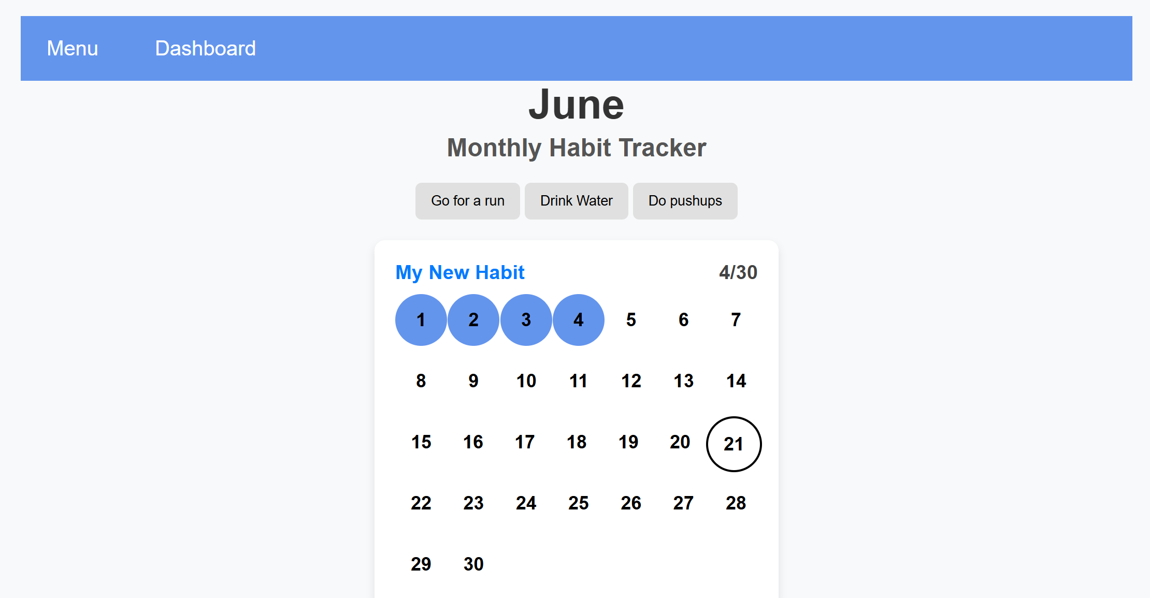

*Figure 3.6: Dynamic calendar with habit buttons display above*

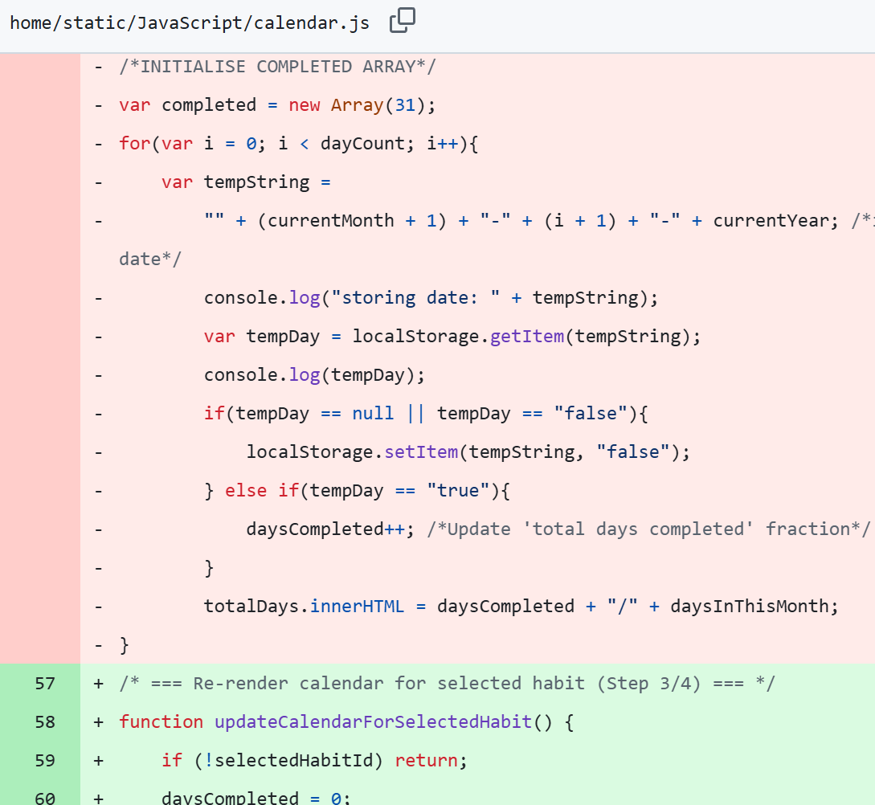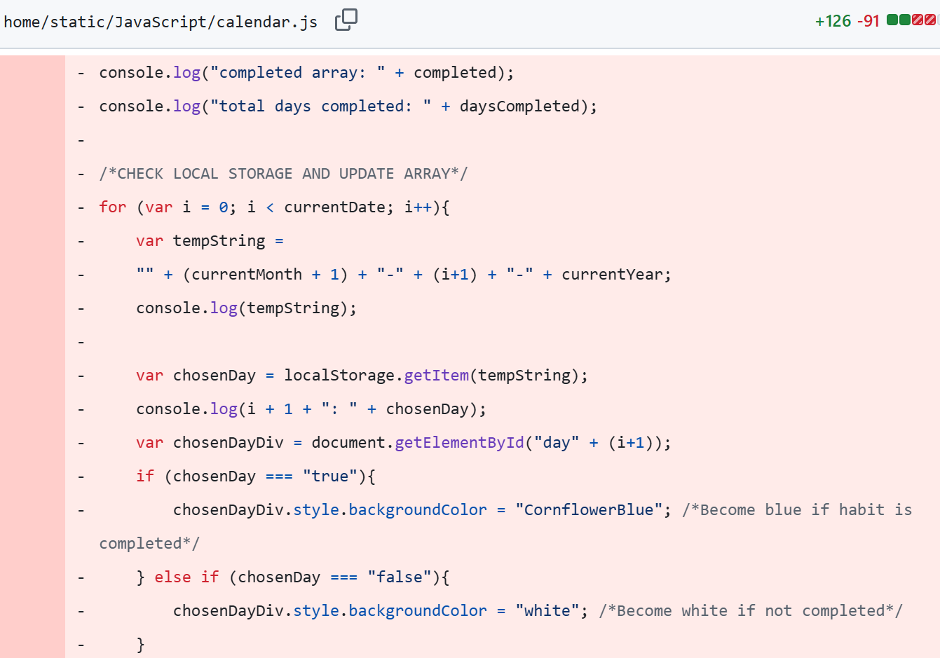

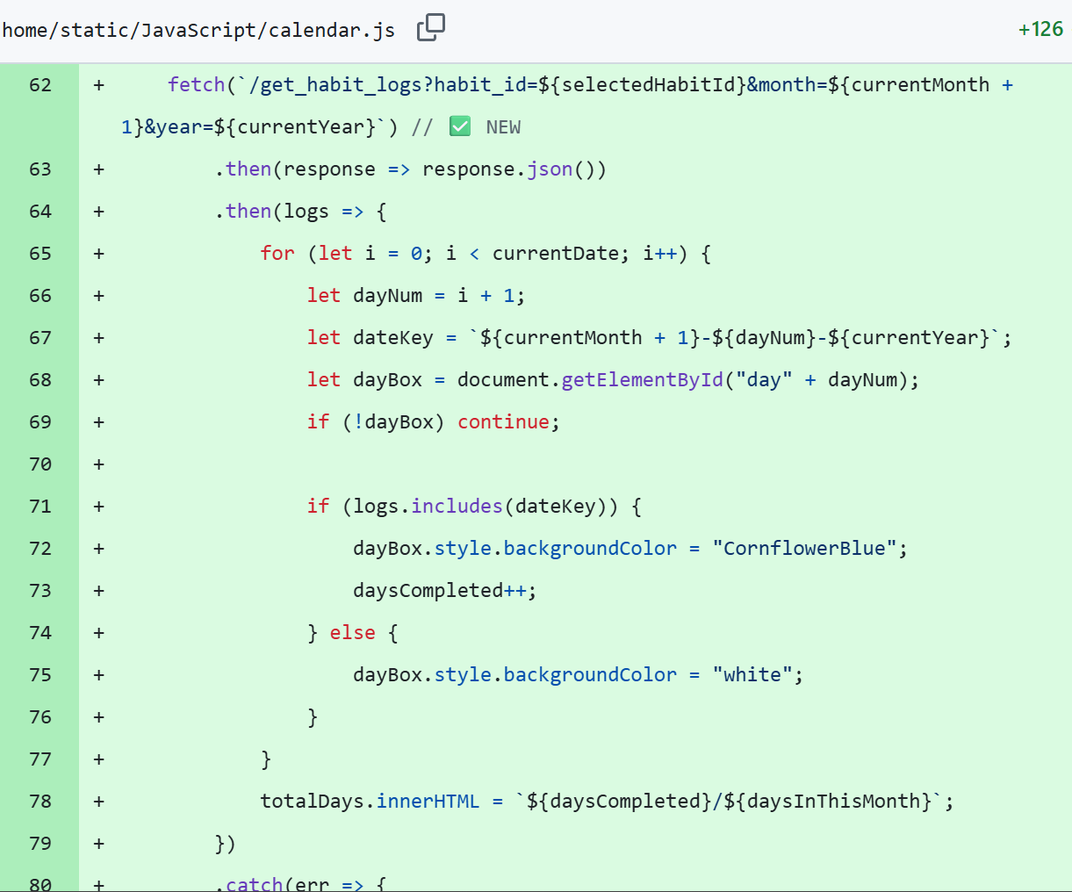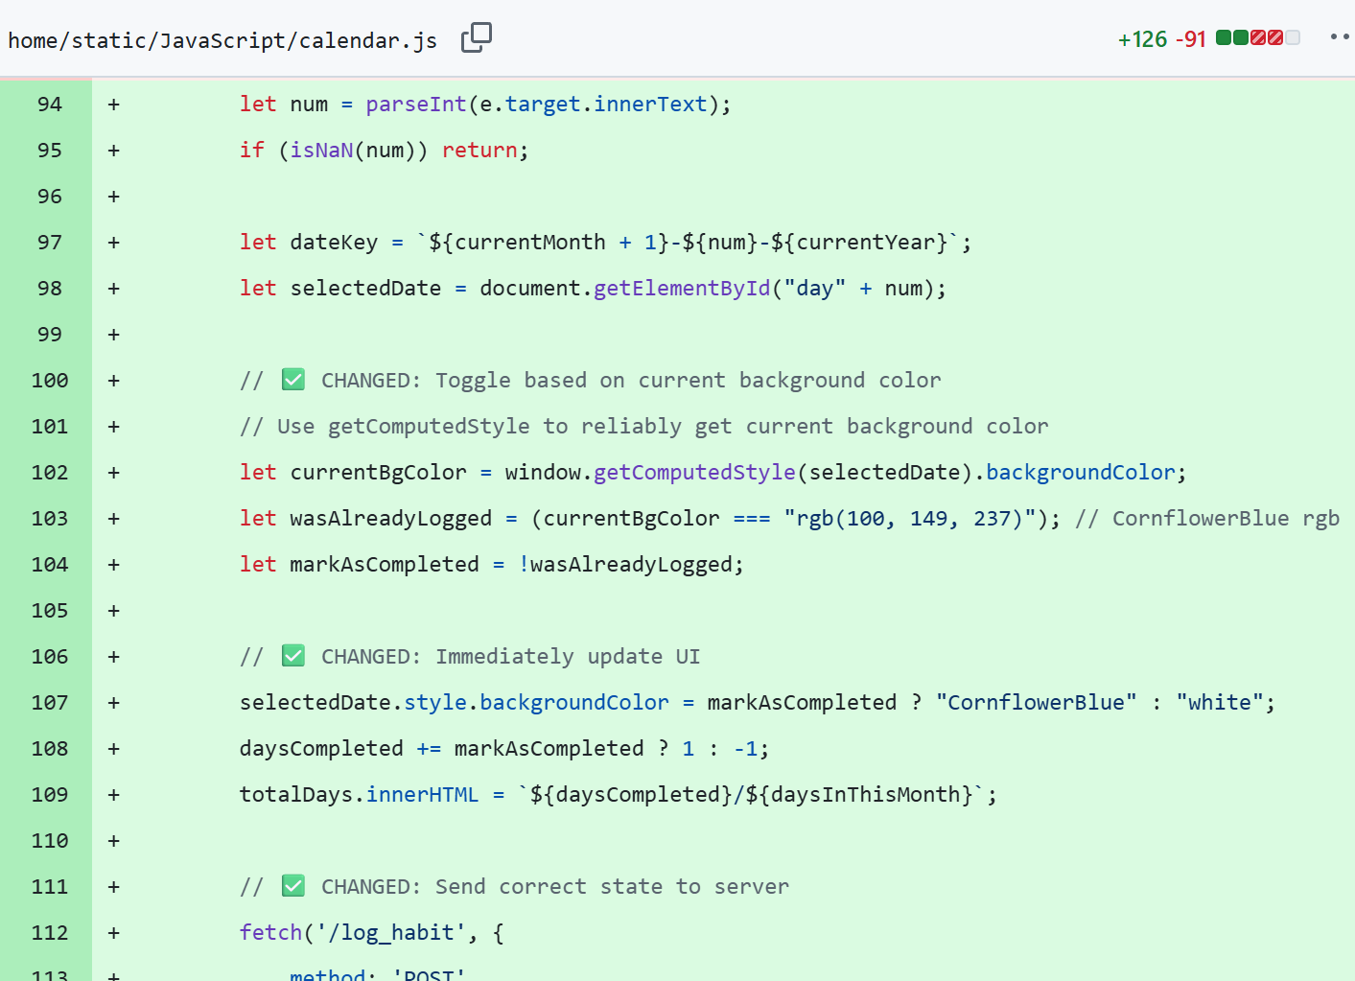

**Evaluation**

Creating the habit logging system was the most daunting task because I knew it involved using JavaScript which I felt unconfident in writing and understanding. To prepare I reviewed the Ed Stem module for JavaScript to learn the basic principles and conventions. The assets available on Ed Stem only teach data collection and saving through form submit buttons. I considered creating a logging system through submit buttons and forms as this would tie into processes I’ve done before and are familiar with. However, I felt this wouldn’t be the most intuitive design and I, personally, wanted to have a different system. After research, I determined Fetch API was the best method for my desired system. I reviewed the use of fetch API (<https://www.youtube.com/watch?v=cuEtnrL9-H0>) and consulted AI on how I could change my system to use Fetch. Doing this myself would have been especially hard as the tutorial I followed before used local storage to update the calendar and I didn’t know how to both remove the local storage without breaking my system and then implement a fetch system. I inputted my JS file to AI and asked it to explain how I could replace my local storage system with fetch. I followed the steps generated by AI and asked it to generate comments to explain what each step was doing. After multiple back-and-forths with AI I managed to create a habit logging system in the JS which would call server routes to save the data to the database. No python file with helper functions was needed as the JavaScript managed data handling and called the different routes itself. Overall, this helped me to convert my JS from a local storage system to a database system which saves states over multiple accounts and habits. I learned more about Fetch API and calling server routes in JS. To continue, I’d like to implement visual indicators of which habit button has been clicked on and continue implementing the other pages of the app such as the dynamic profile page.

Date: 23/06/25 – Dynamic Profile Page

**Progress**

|  |  |
| --- | --- |
| Achievements | Stumbling Blocks |
| * Dynamic profile page created * Visual indicators for selected habit buttons | * Handling file uploads * Allowing only safe file types |

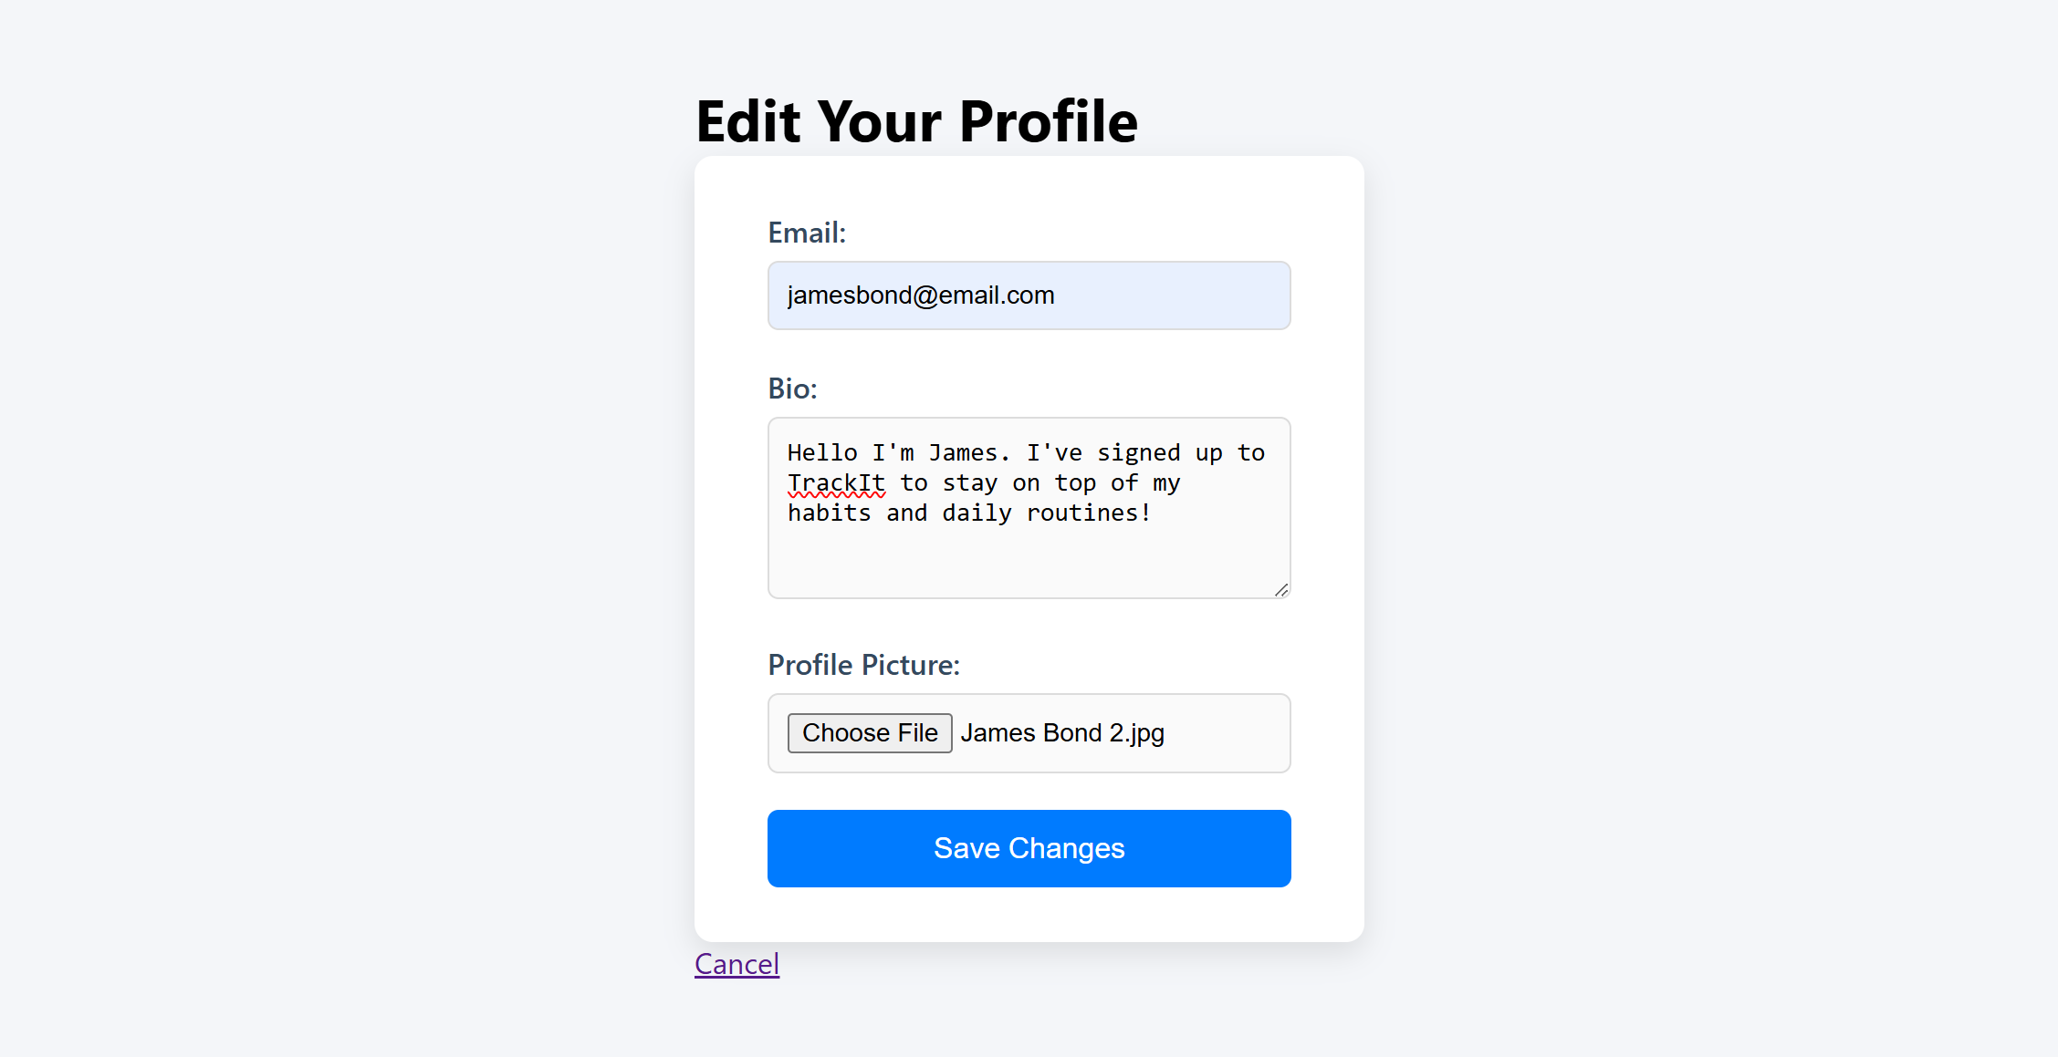

*Figure 3.7: Edit Profile Form that allows for email input, text input, and file uploads. Contains optional cancel button or save changes button.*

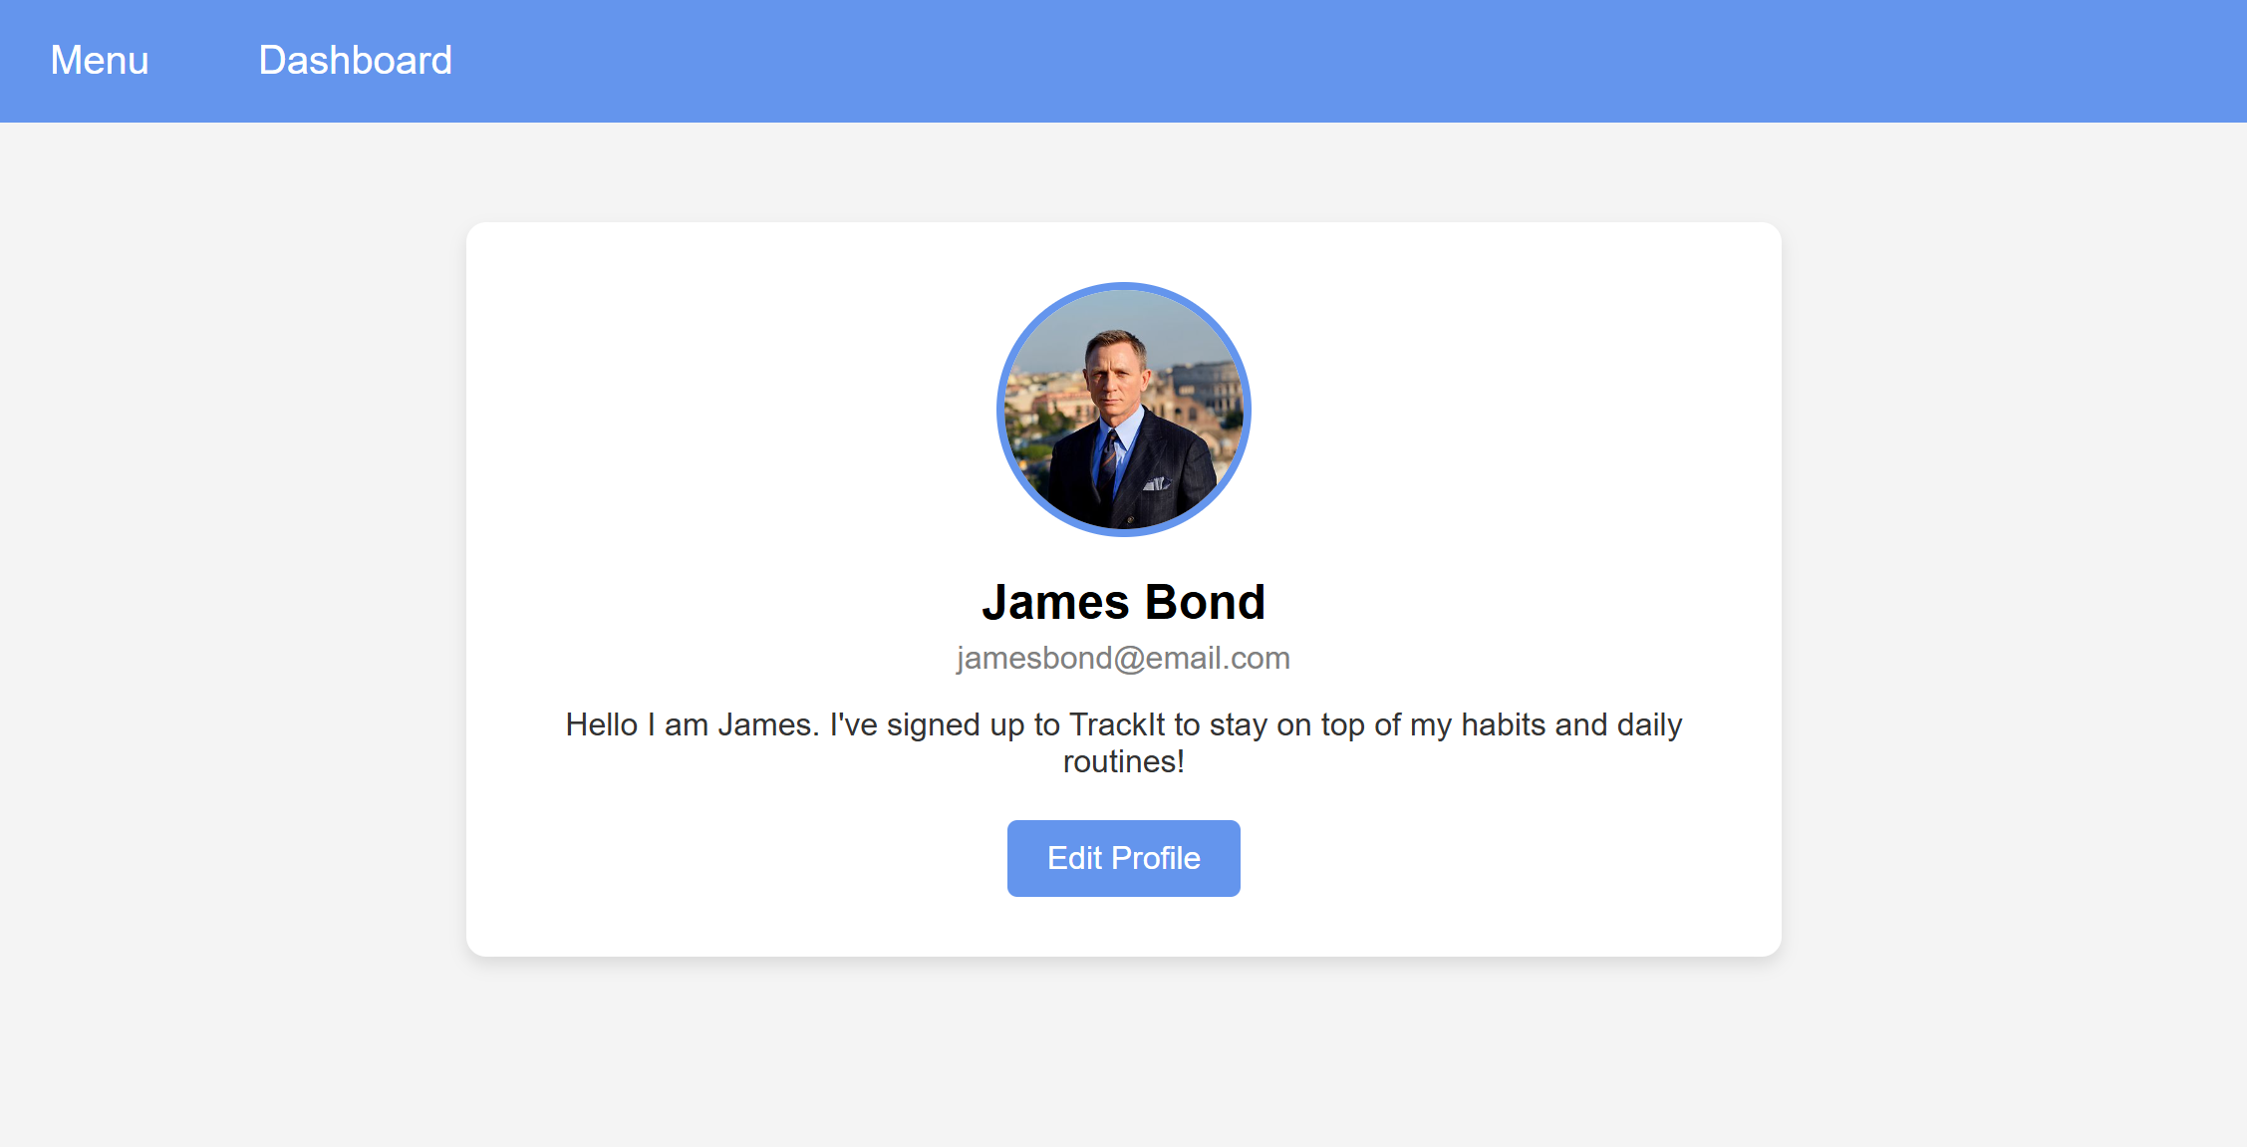

*Figure 3.8: Dynamic Profile Page which displays inputted information*

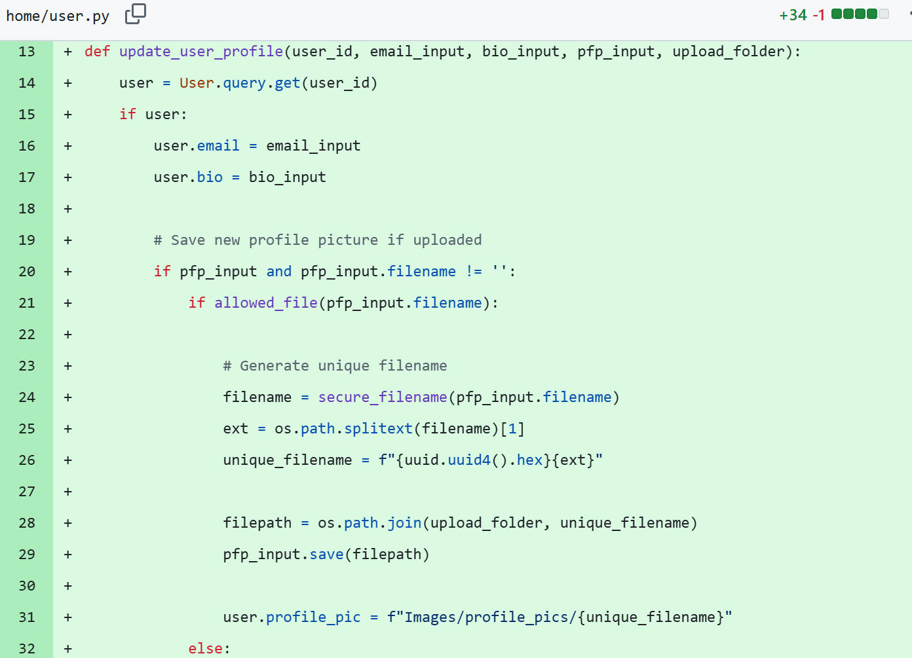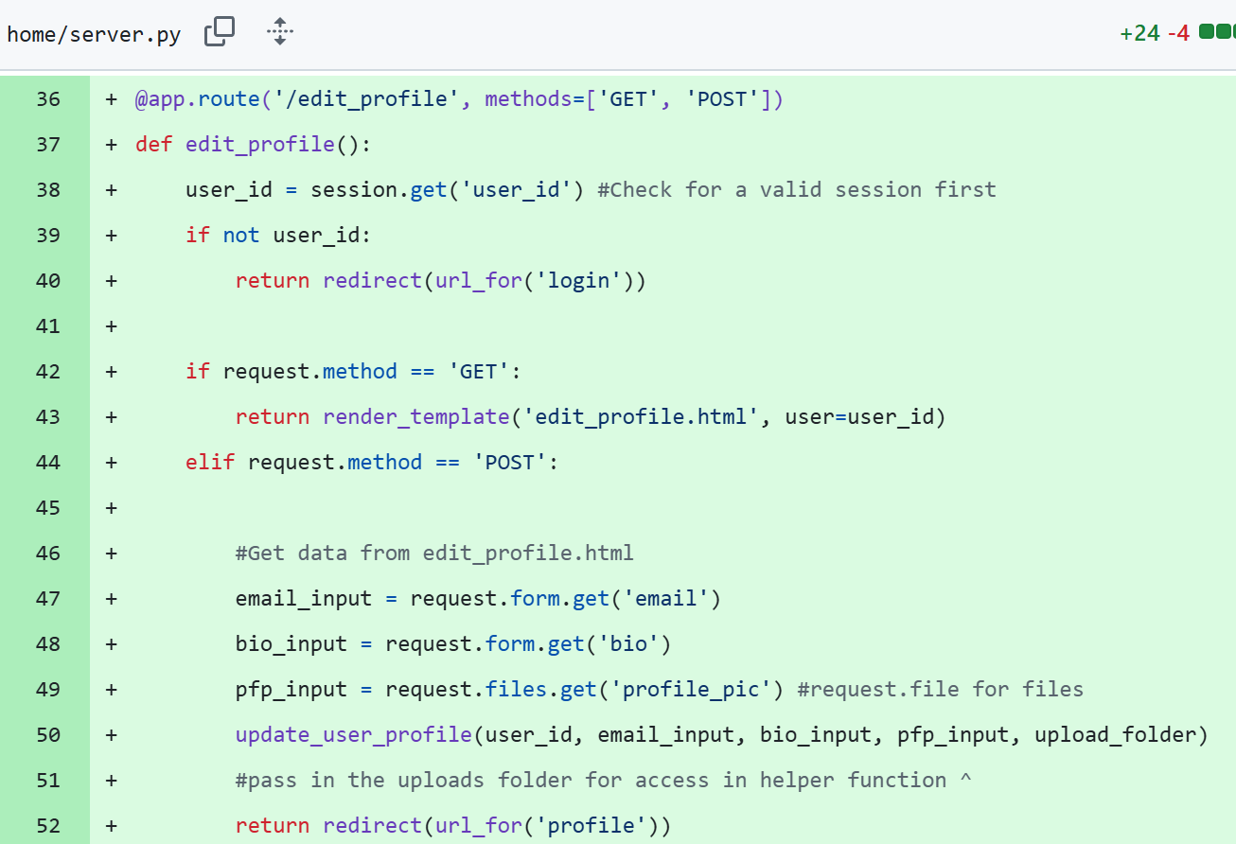

**Evaluation**

Making the profile page dynamic was, for the most part, not so difficult as I had already made the username displayed on the profile page dynamic and applied the same logic to all the other attributes of the user class. As the user does not have to sign up with an email or bio, I set nullable to True in the data file. Once I got to uploading and displaying the uploaded profile picture dynamically, things got complicated. I imagined my app to have file uploads for profile picture so I was determined to figure out how to code this feature. I started by reading up on secure file uploads (<https://www.pullrequest.com/blog/secure-file-uploads-in-flask-filtering-and-validation-techniques/>, <https://blog.filestack.com/simple-secure-file-uploads-flask/>) which gave me a decent understanding of what type of code I had to write. I followed the code examples from the articles and applied this to my own app. However, as I had no experience with writing code for secure file uploading, I made sure to put my new code snippets into AI and asked it to check that the logic made sense. It gave suggestions such as helping me write the file path out correctly, as my file path included more subfolders than the examples in the articles. Utilising both the articles and AI help, I was able to get the file uploading to work and have it only upload specified file types. I followed the article’s example (png, jpg, jpeg, gif) but left out txt and pdf as I only wanted images. I feel this process helped me understand coding around secure file uploads and has made similar code more interpretable in future instances.

Date: 26/6/25 – Edit and Delete Habit Buttons

**Progress**

|  |  |
| --- | --- |
| Achievements | Stumbling Blocks |
| * Edit and Delete habit buttons created * Logs are deleted with habit * Calendar displays correct days in month when no habit selected | * Deleting logs that are attached to the deleted habit * Deleting ghost logs * Styling habit buttons to only use colour and hover functions when activated |

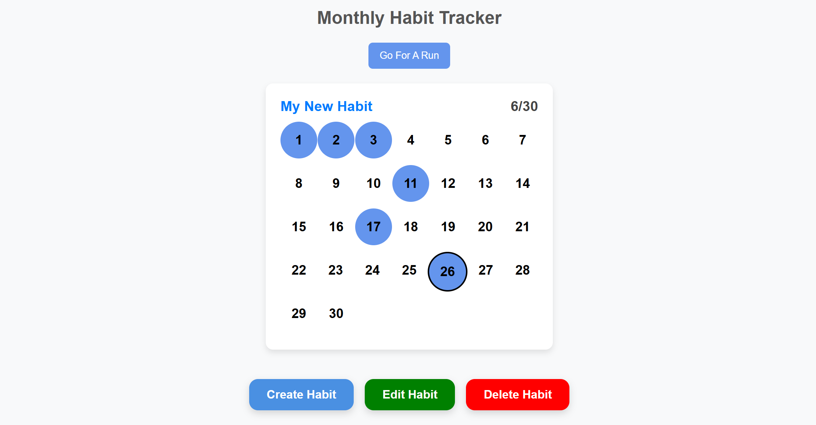

*Figure 3.9: Create, Edit, and Delete buttons for selected Habit*

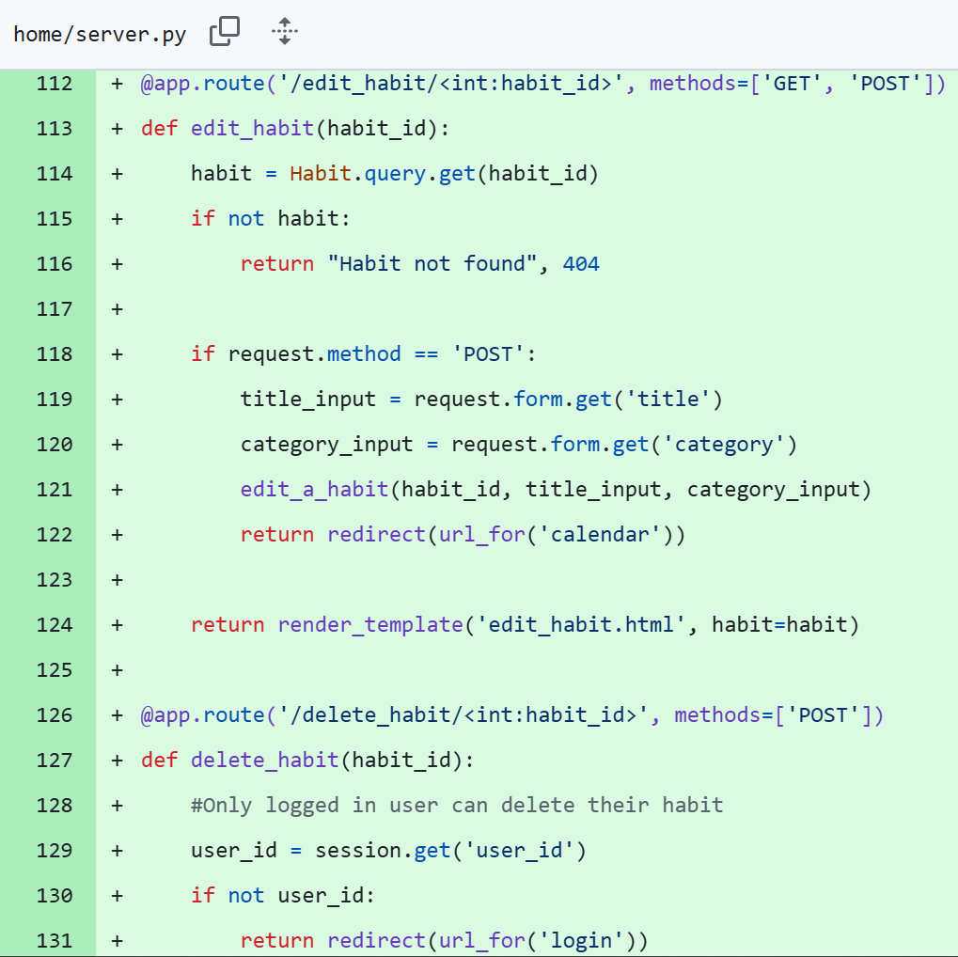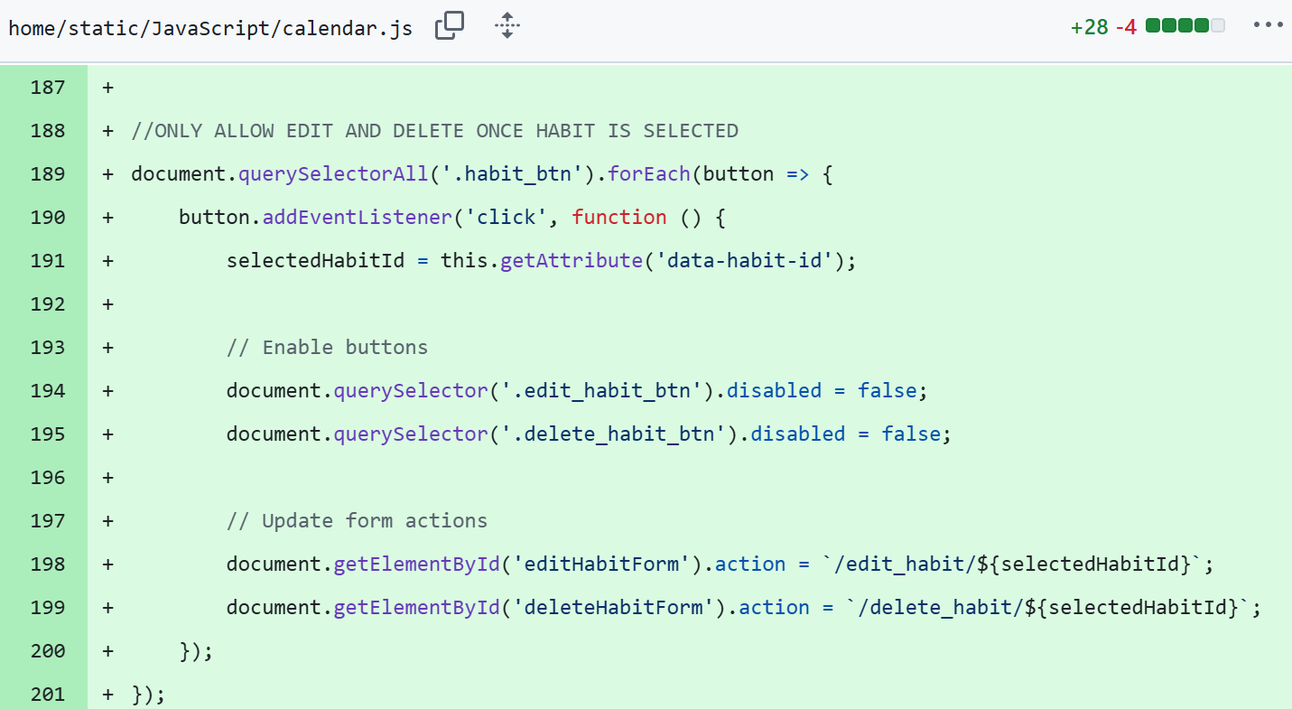

**Evaluation**

Creating edit and delete buttons for habits was an essential feature as this provided functionality for all CRUD operations. Setting up the buttons and their functionality was not too difficult as I already had a create habit button, so applied most of the logic to two new buttons. The edit habit button mostly copied the same logic as it would redirect the user to a form where they would input the new information and it would update the database accordingly. The Ed Stem ToDo list was also a helpful resource as it contained similar logic. Deleting the habit was a little more difficult but I could still apply the logic from Ed Stem to my app. The only problem I encountered was deleting the logs that were attached to the deleted habit. I researched this problem and found an article detailing Cascade Deletes in python (<https://medium.com/@eduardo.heyer12/simplifying-database-relationships-with-cascade-all-and-delete-orphan-in-python-e842925e8a58>). I then proceeded to find examples of this written in python code, applied this to my app, and fixed the problem. Overall, this achievement wasn’t as difficult but still essential. Continuing, I’ll look to implement either the shop or community. It may take a while to do both as I have no experience programming these areas.

Date: 5/7/25 – XP Bar and Levelling

**Progress**

|  |  |
| --- | --- |
| Achievements | Stumbling Blocks |
| * XP Bar displayed on calendar page * XP bar updates when habits are logged and unlogged * User levels up when a certain number of XP is reached * XP and Level are specific to a habit category * XP threshold updates depending on level | * Levelling the user down when logs were removed * Displaying the correct XP threshold for each subsequent level * Removing appropriate XP level when using reset button * Removing ghost logs for unfair levelling * Fixing negative XP display |

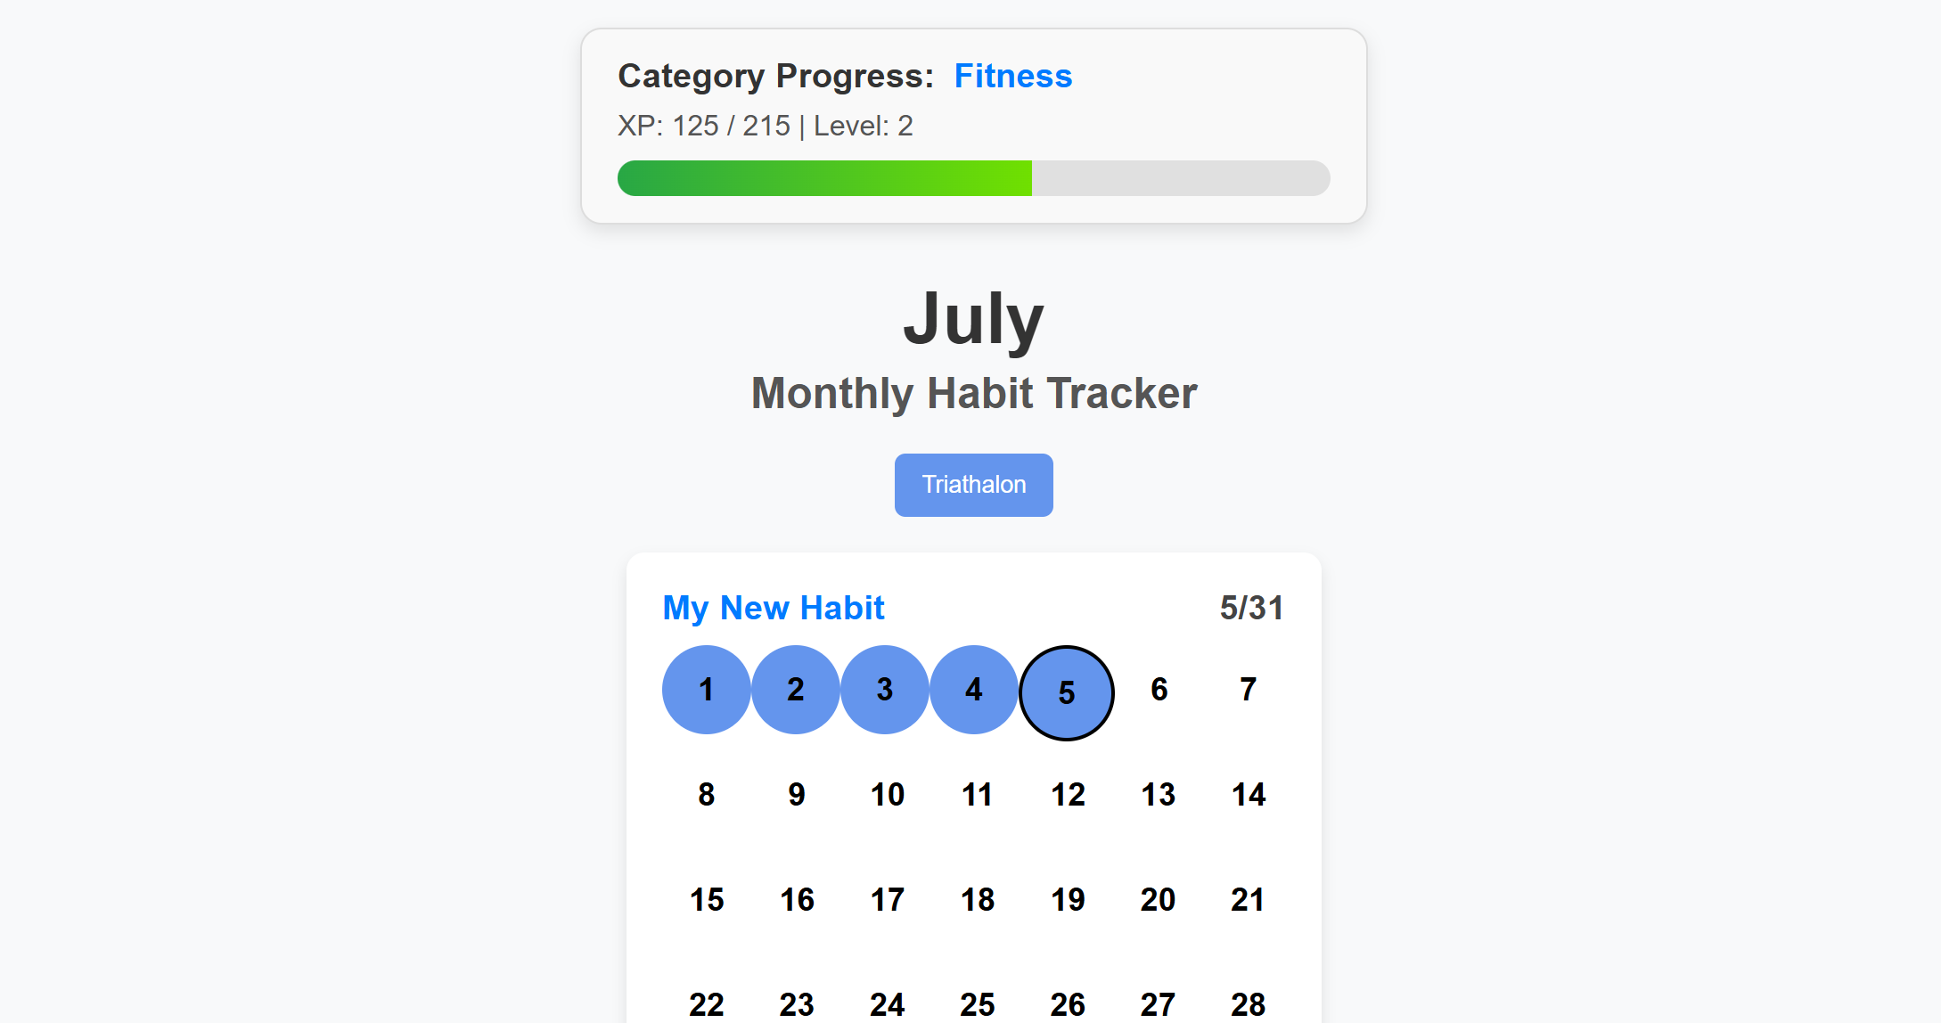

*Figure 3.10: XP bar on calendar page displaying new threshold for level 2*

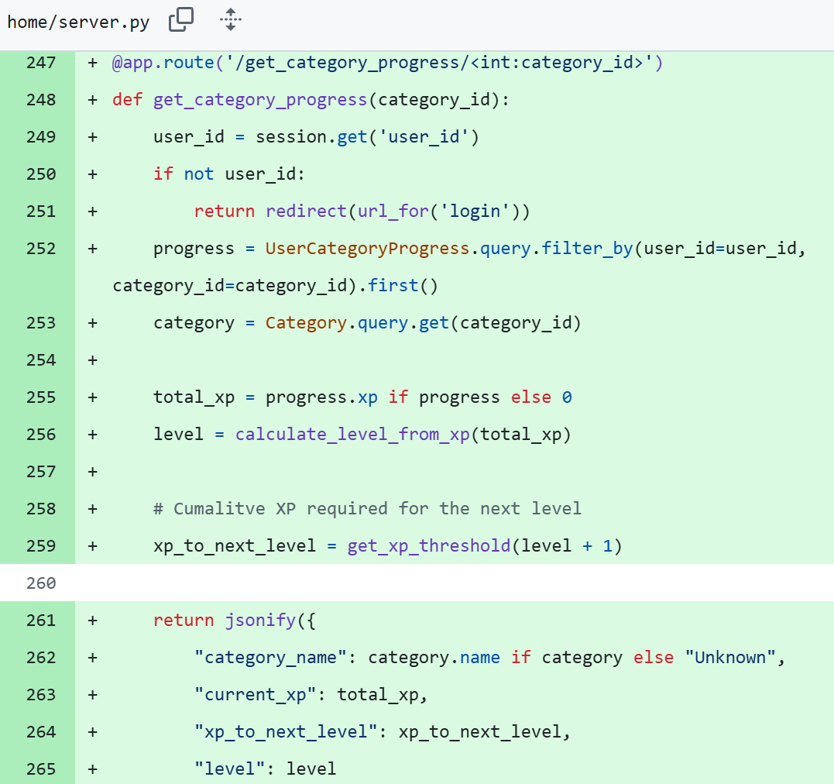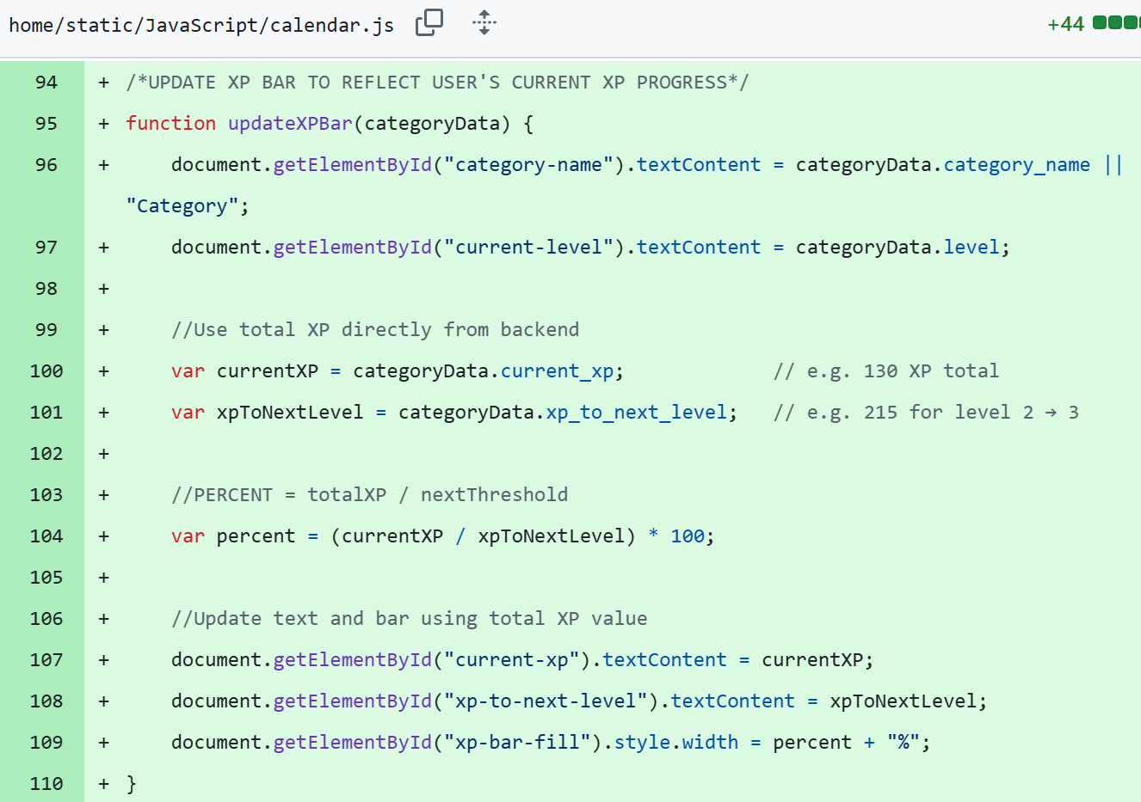

**Evaluation**

Getting the XP bar to work was a challenge. I meant to finish it by the 1st of July but it took me until the 5th. Originally I was trying to have dynamic threshold updates and have the user’s XP reset to 0 at every level. E.g. Level 1: 0/100, Level 2: 0/115, etc. Trying to get this working caused the most problems as the threshold would never update correctly and either display an incorrect threshold (Level 2: 0/15) or an incorrect XP amount (Level 2: -100/115). To fix this problem, I simplified the logic for the XP bar to instead always display the user’s total XP and have the threshold update for each level. E.g. Level 1: 0/100, Level 2: 100/215, etc. This way the user would have to earn the same amount of XP as the system beforehand but the XP bar would be accurate. However, the trade-off for this is that the bar always looks half-full, possibly eliminating the purpose of having the bar. Nonetheless, the functionality works which justified this approach. The whole XP and levelling system will be used to create the shop where users can purchase some form of in-game item (still deciding what). Continuing in the project, I’ll try and work out a system for translating XP into in-game currency for purchasing at the shop.

Date: 6/7/25 – In-Game Shop and Currency

**Progress**

|  |  |
| --- | --- |
| Achievements | Stumbling Blocks |
| * XP adds and subtracts appropriately when editing habit category * Created coin counter * User earns coins for levelling up * Coin counter has glow animation * Shop page created * Shop filled with items * Items have in-game effects | * Dynamically updating coin counter * Making glow animation on coin counter work * Designing a model for items to have in-game effects |

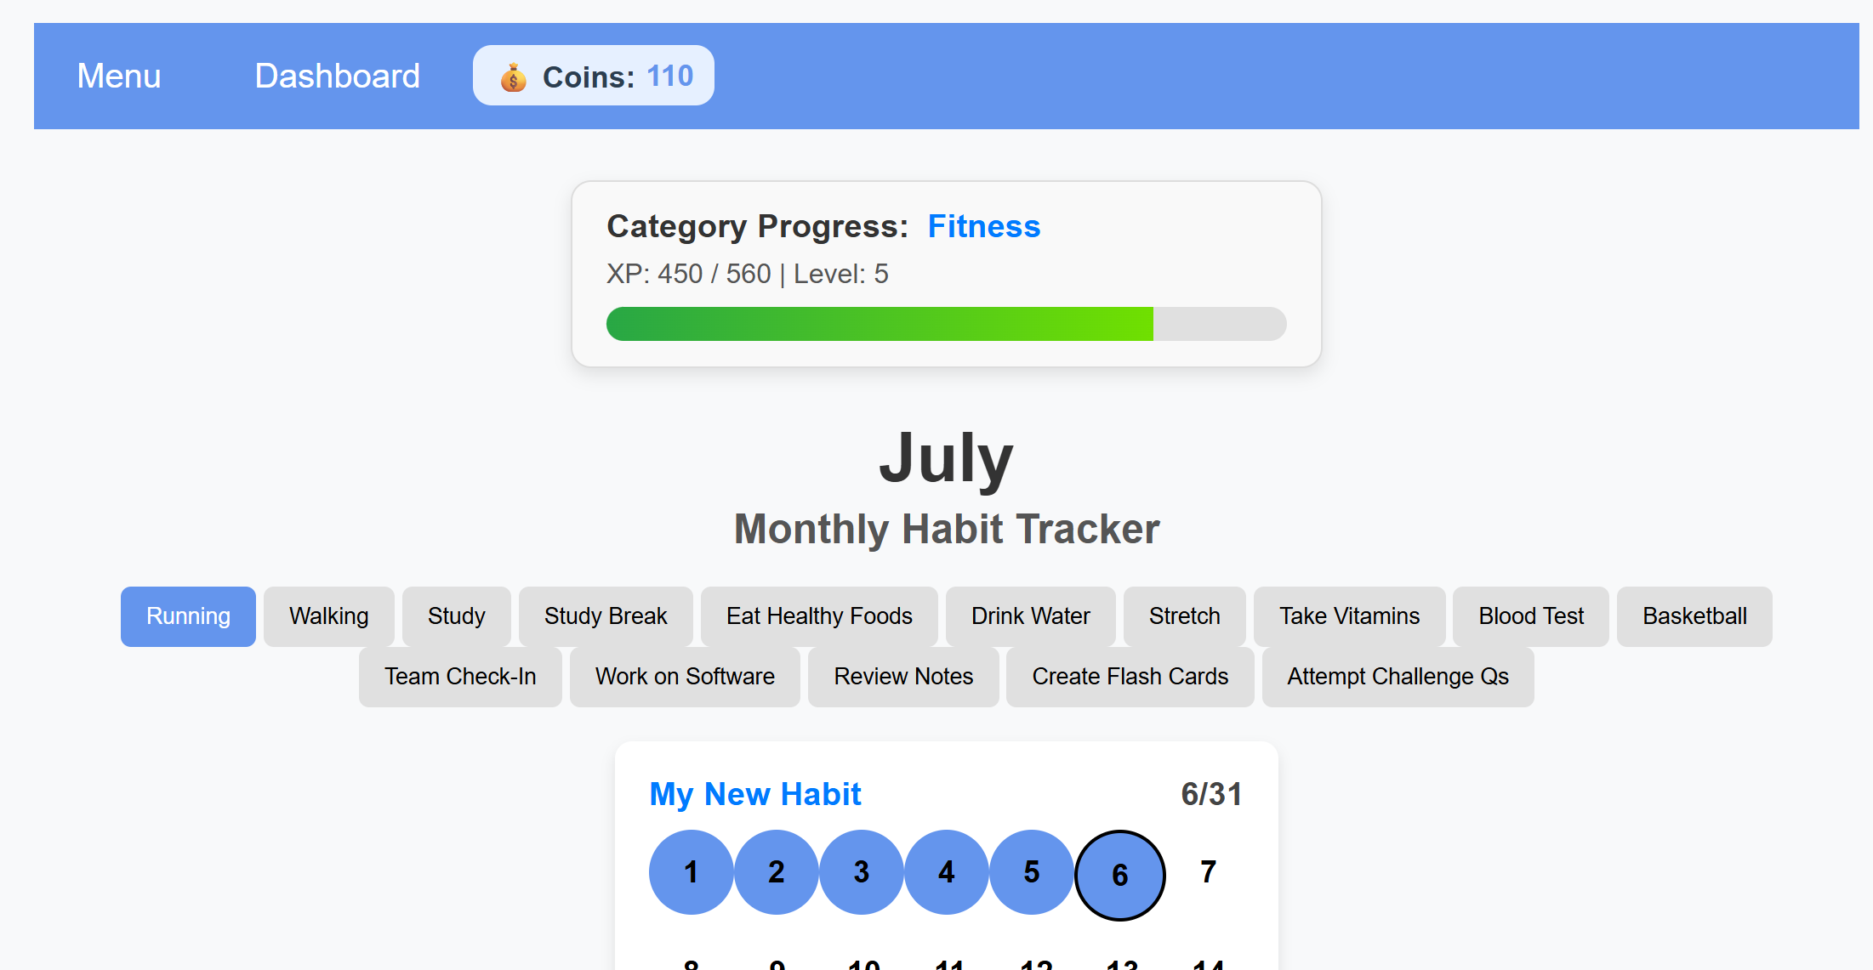

Figure 3.11: Nav bar that displays the user’s amount of coins

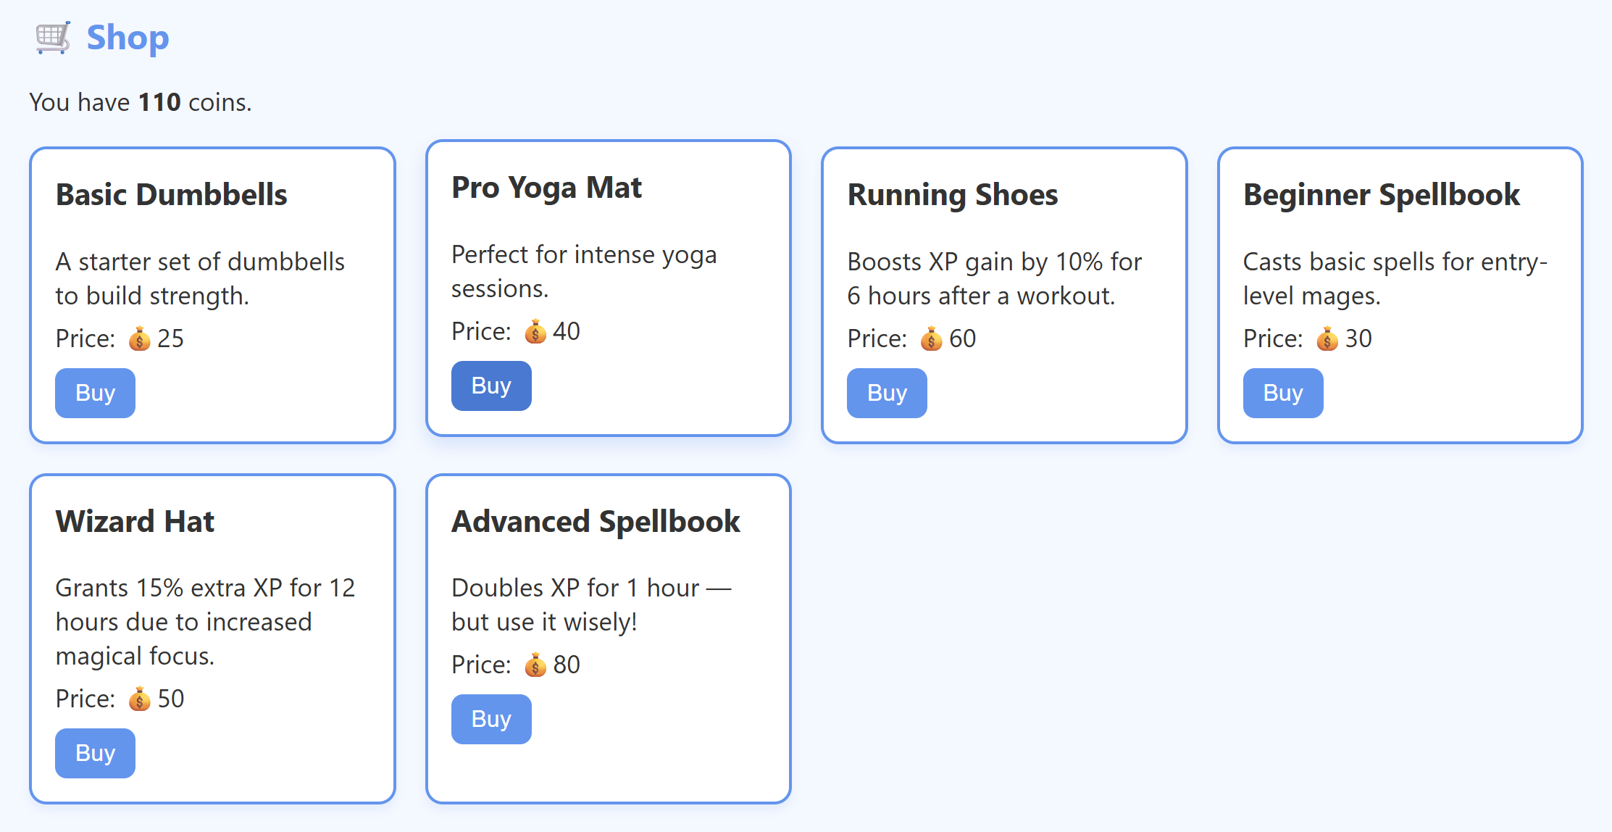 Figure 3.12: Shop screen populated with test in-game items, descriptions, and prices. Items have option for purchasing.

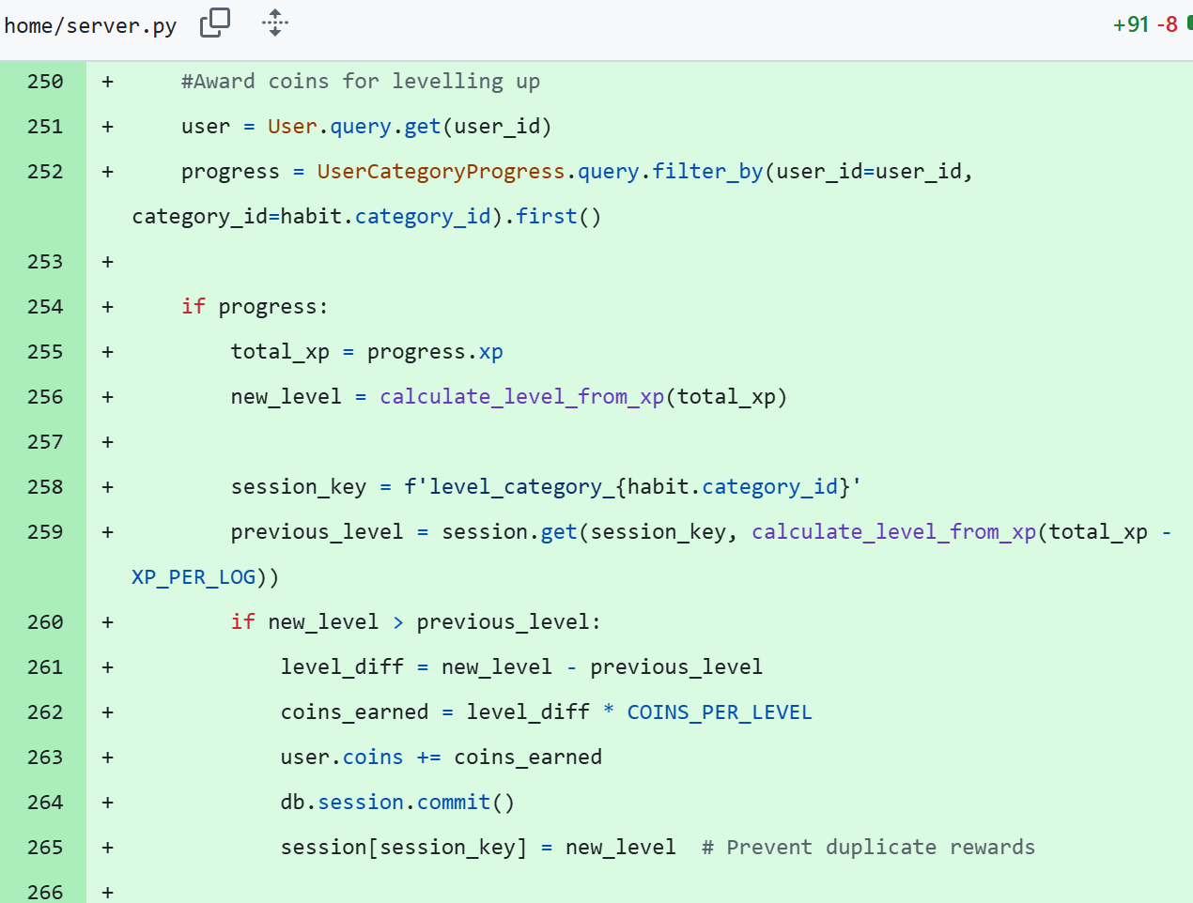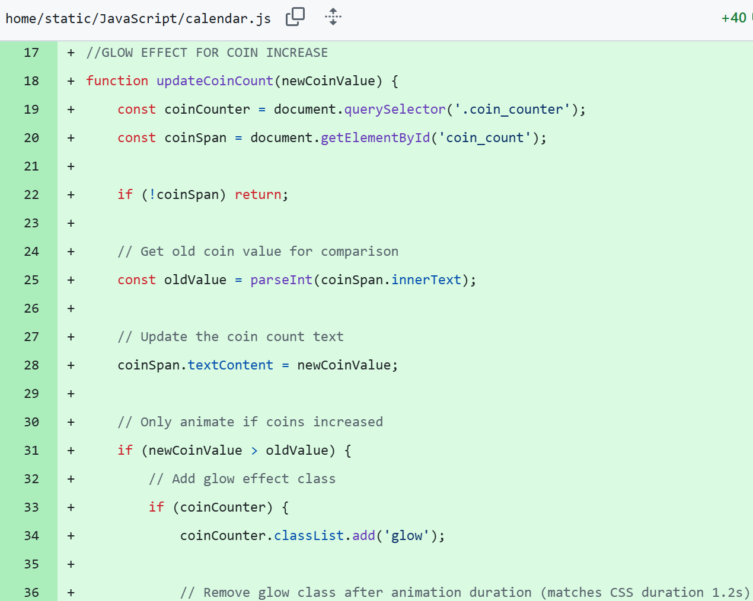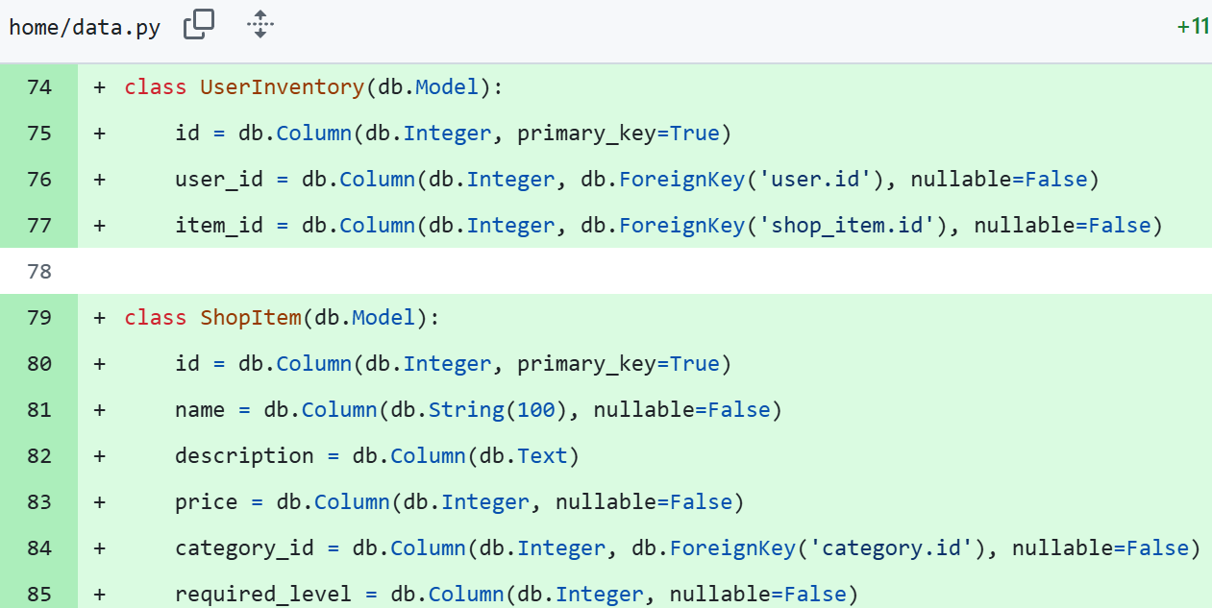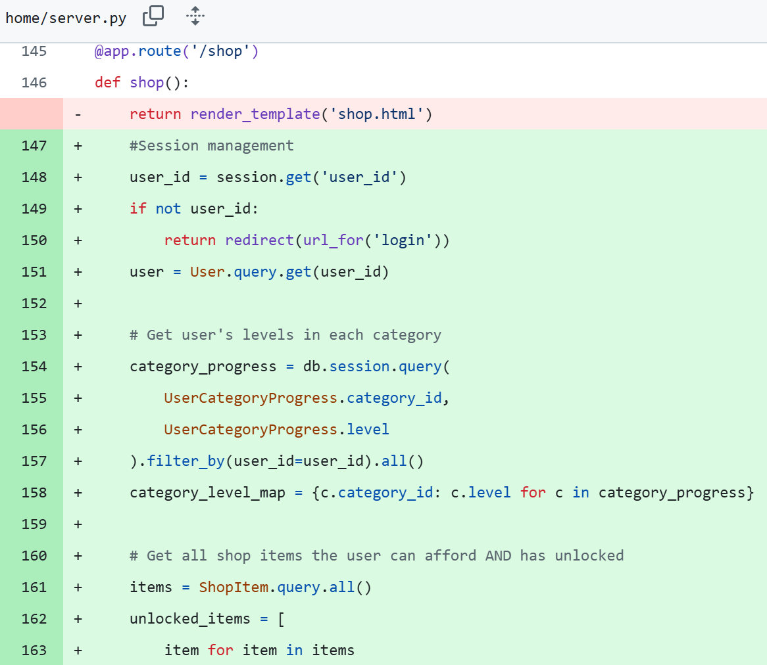

**Evaluation**

To create the coin counter, I added a new attribute to the user class to store the amount of coins they had. I then passed this into the nav bar to be displayed. To increment it, I used an IF loop to check whether the user had gone up a level. If they had, they would be awarded a set number of coins. Their level up is stored in the session so that re-achieving a level up wouldn’t reward them again. This stops users from continuously logging and deleting to gain infinite coins. For the glow effect when gaining coins, I asked AI on steps to code this as this was something I had no experience with. From its output I learnt about keyframing, running animations in CSS, and coding this functionality in JS. The JavaScript logic involves detecting when the coin counter increases and then applying the glow class for a set time to the coin counter. After the set time, the glow class should be removed, achieving the desired effect. I can now interpret keyframes and css animations better and understand their application in JS. To create the shop, I determined I first had to create a database model for in-game items and an inventory for the user if I wanted to display their inventory. I then used similar logic I’ve used previously on the calendar for displaying habits to display the items the user has unlocked, querying them by level and price to only show items the user has unlocked and can afford. Purchasing an item, adds the item to the user’s inventory model, allowing their inventory to be displayed so the user can see what items they have. Right now the effects on the items do not work. I have just created a template for different effects but no effects work right now. I plan on creating effects like ‘XP boost’, ‘coin multiplier’, and others in the next log.

Date: 9/7/25 – Boost Items

**Progress**

|  |  |
| --- | --- |
| Achievements | Stumbling Blocks |
| * XP boost and coin multiplier items added into store * Item quantities are displayed in user’s inventory | * Deciding best approach for effect items |

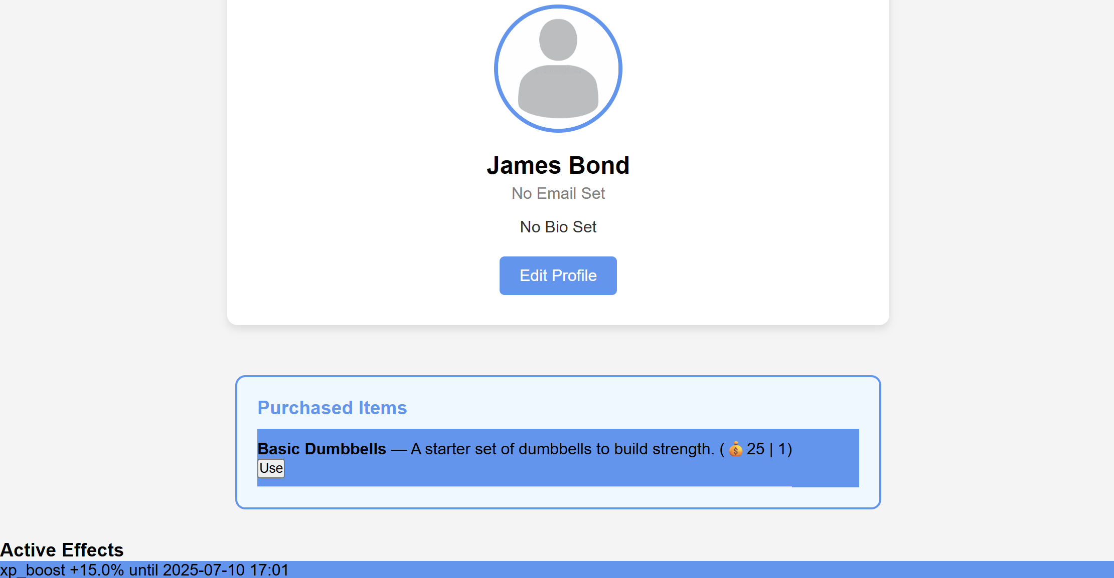

*Figure 3.12: Profile page with user’s purchased items and any effects that are currently active*

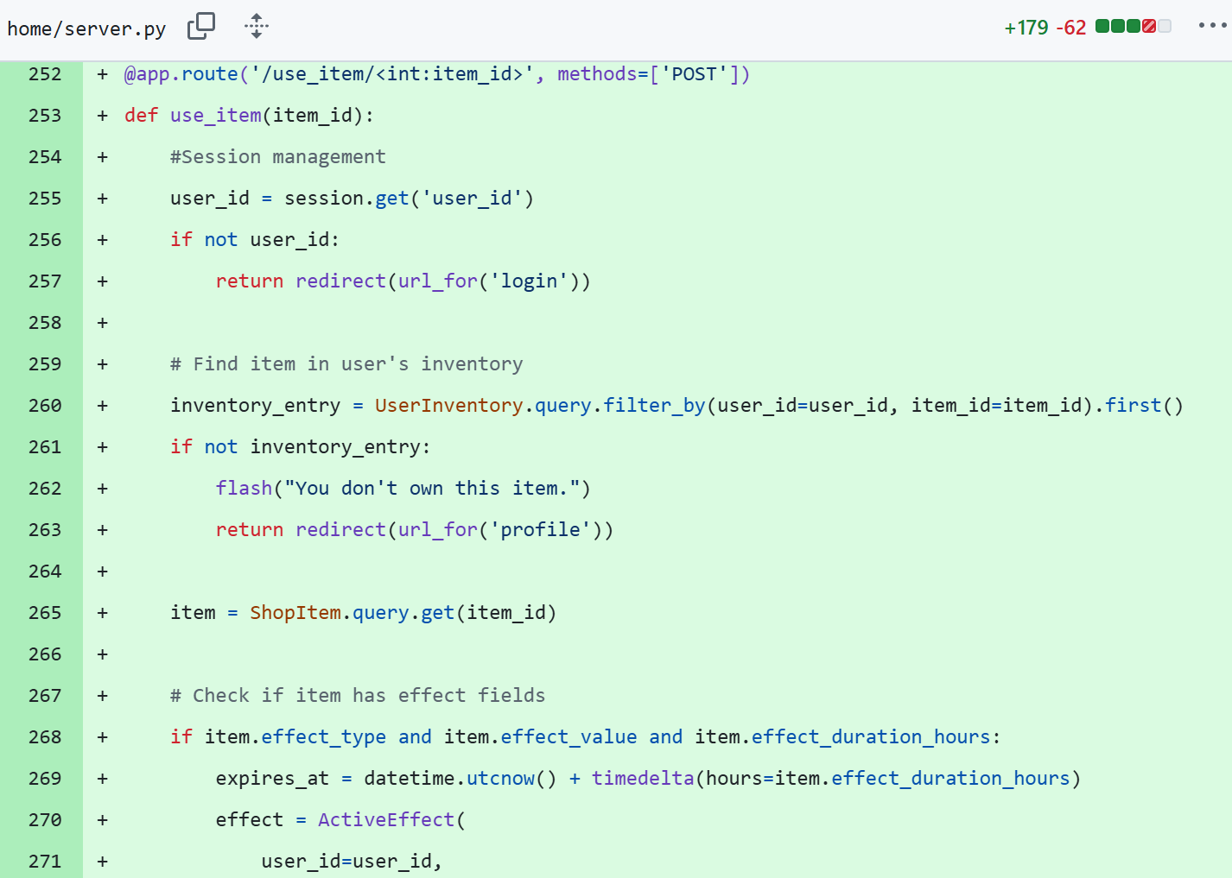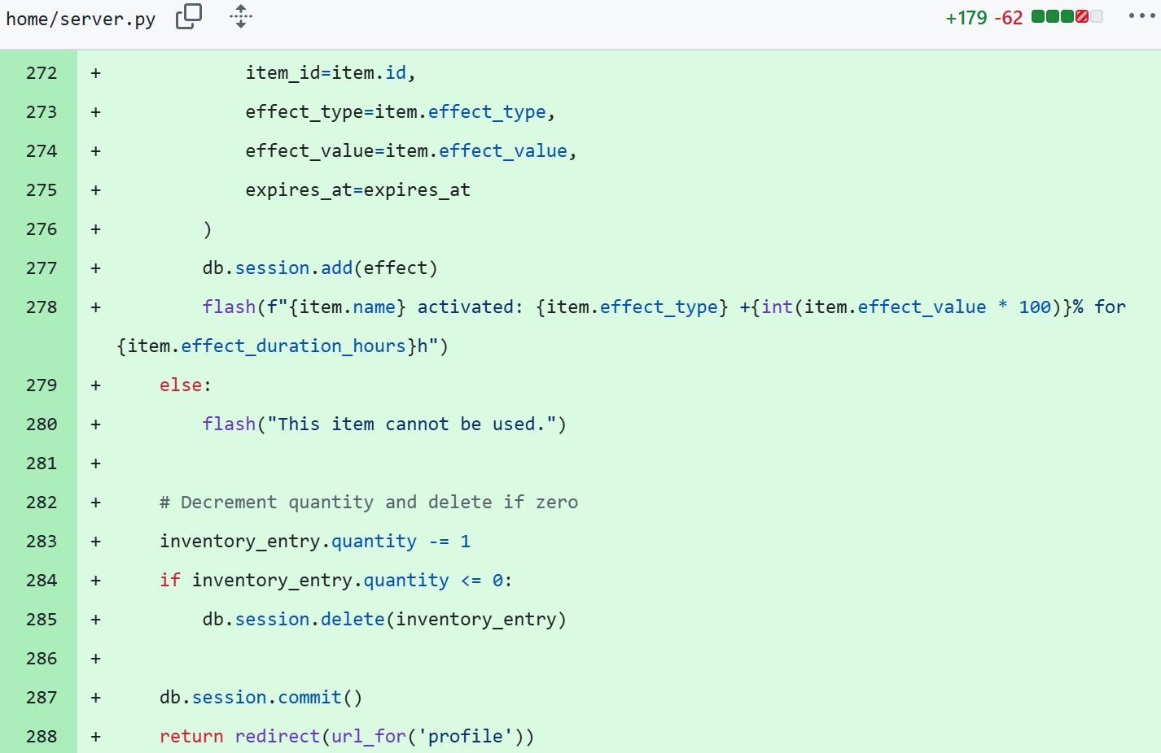

**Evaluation**

Creating the XP boost and coin multiplier effects was not as difficult as I thought it would be. Originally, I thought it would be tough to change the current logic for adding XP and coin amounts. However, I got around the problem by adding extra variables to my data models which allowed items to store what type of effect they are. Then, I changed the XP logic to always be checking if any XP boosts are active, if any are it will multiply the original XP amount by the boost. If there is not, then the original XP amount will be added like normal. This way when a user uses a boost item, the multiplier will automatically be accounted for. I applied the same logic to my coin adding system for coin multipliers. I also added an attribute to store a quantity so if a user buys an item with the same id (i.e. the same item from the shop) the item won’t appear twice in their inventory and instead they’ll see the item once with the number of that item they have. I also wanted to change the XP removal system to store the specific time when logged so that it can check if a log was created during an XP boost. This way when a user removes logs or uses the rest button during a boost, they won’t lose an excess amount of XP. However, I expect this feature to take a long time to implement, and it is not an essential feature. Thus, I will focus on other features and if there’s time left over, I will implement this feature. I plan on trying to finish up with the shop and then moving onto the community page. I also wanted to add pictures for the shop however, this is the same as the other aforementioned wish list feature; Not an essential and will add if there’s time leftover.

Date: 10/7/25 – General app fixes + Day Names

**Progress**

|  |  |
| --- | --- |
| Achievements | Stumbling Blocks |
| * Flash item purchase confirmation * Input validation on habit title * New text input feature for custom calendar message * Day names displayed above days | * Getting the current day (Tuesday, Friday, etc) from the current date (2025/07/10) |

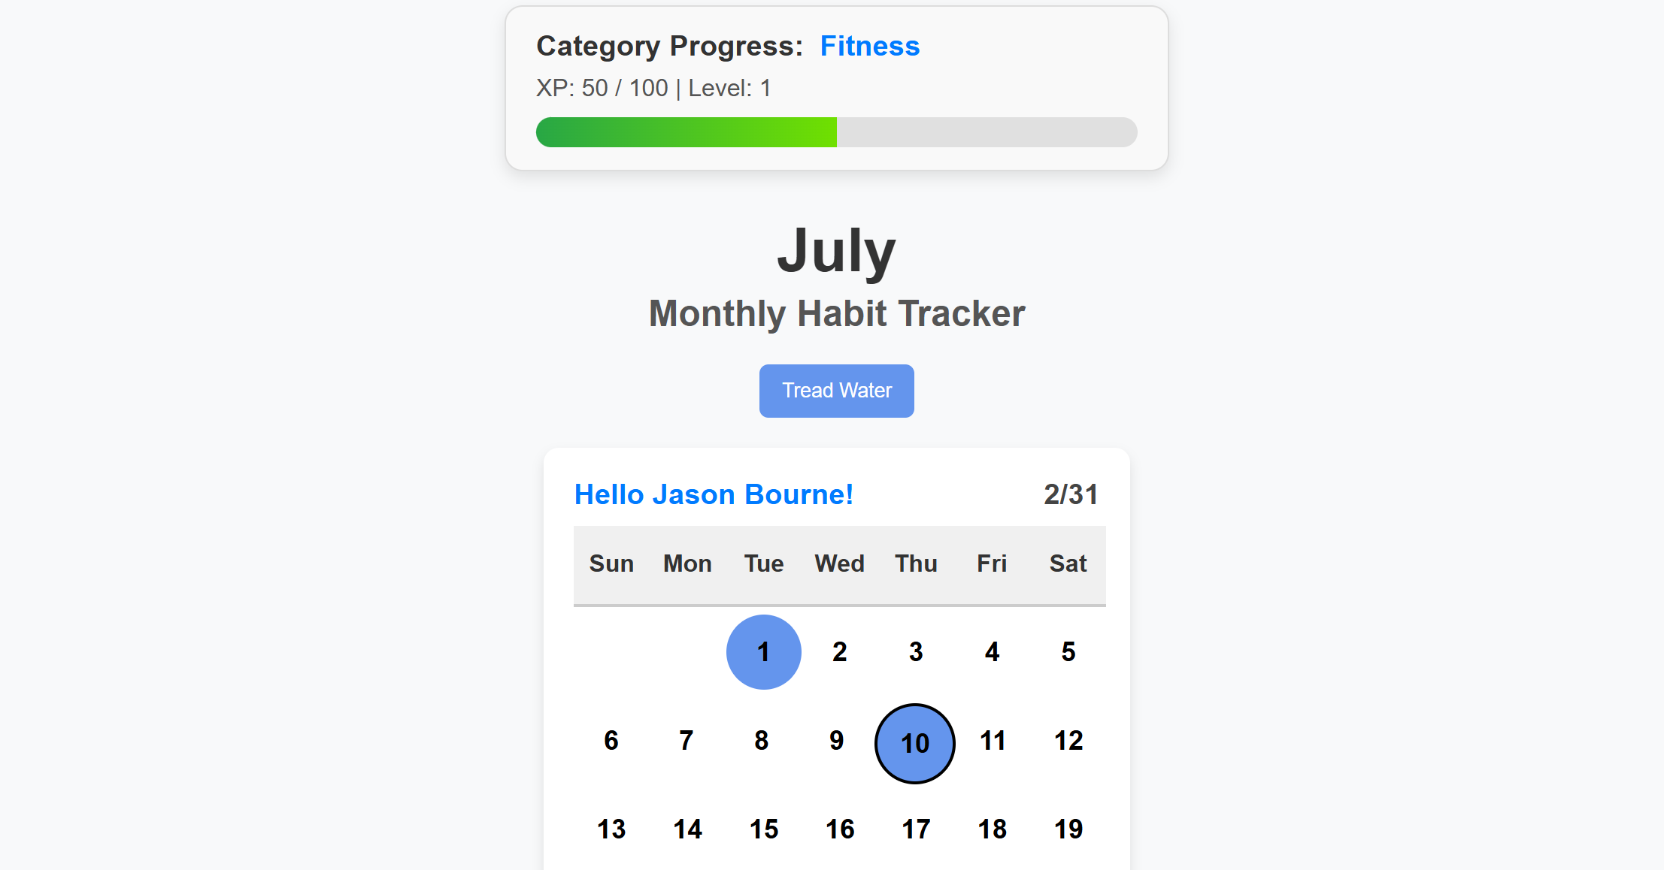

*Figure 3.13: Day names displayed above calendar columns. Personalised greeting displayed in top left corner of calendar.*

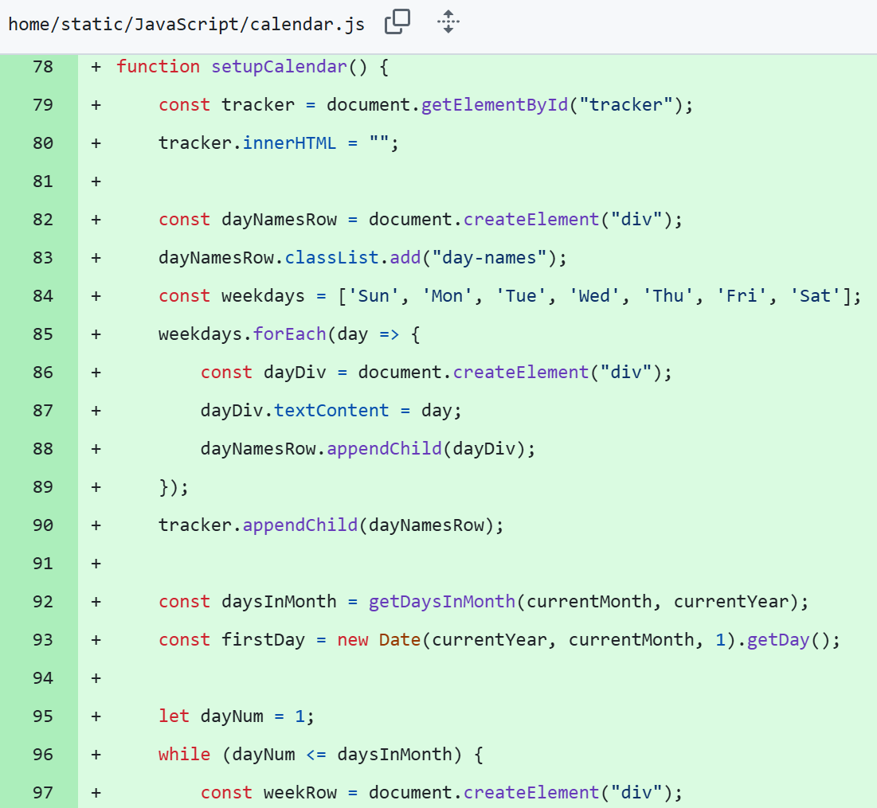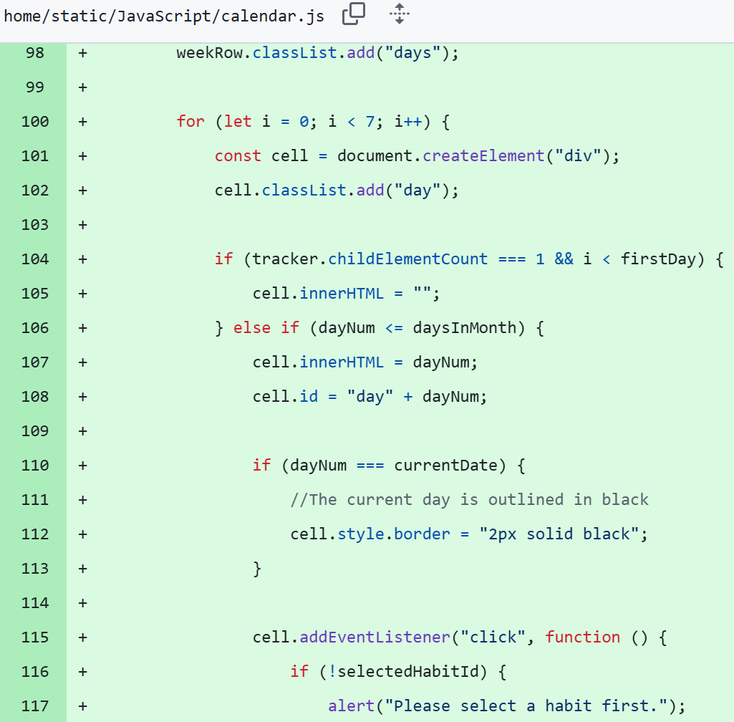

Evaluation

To add the day names to the top of the calendar, I used the get day function in JavaScript. I started by adding another div class that has all the day names in my HTML file and created appropriate styling for this. Then I went into my JS file and used the get day function (which I learnt from this article <https://developer.mozilla.org/enUS/docs/Web/JavaScript/Reference/Global_Objects/Date/getDay>) of the first day of whatever the current month was. Depending on what value it returned, I would leave empty cells in front of the first day so that the calendar would filter accordingly. E.g. for July, the first is a Tuesday so the function would return 2. That means I’d leave 2 empty cells (for Sunday and Monday) and then start creating the clickable days with filled in text in the third cell (which would be Tuesday). My old create calendar function already put 7 days in one row before starting a new row so this allowed all days after the first to filter accordingly down the calendar. Going forward, I’d like to start on the community page as this is the final aspect of my app I had in the documentation that I have still not yet done.

Date: 11/07/25 – Friend Request System and Community Page

**Progress**

|  |  |
| --- | --- |
| Achievements | Stumbling Blocks |
| * Created community page * Implemented friend request system * Created inbox for receiving friend requests * Users can accept or reject a friend request * User’s friends are displayed on their profile * Profiles on community are marked with status (friends, pending, or send friend request) * Friends are displayed with their top 3 habits (ranked by number of logs) | * Sorting through habits to find an account’s top 3 * Writing JS for accepting and rejecting friend requests |

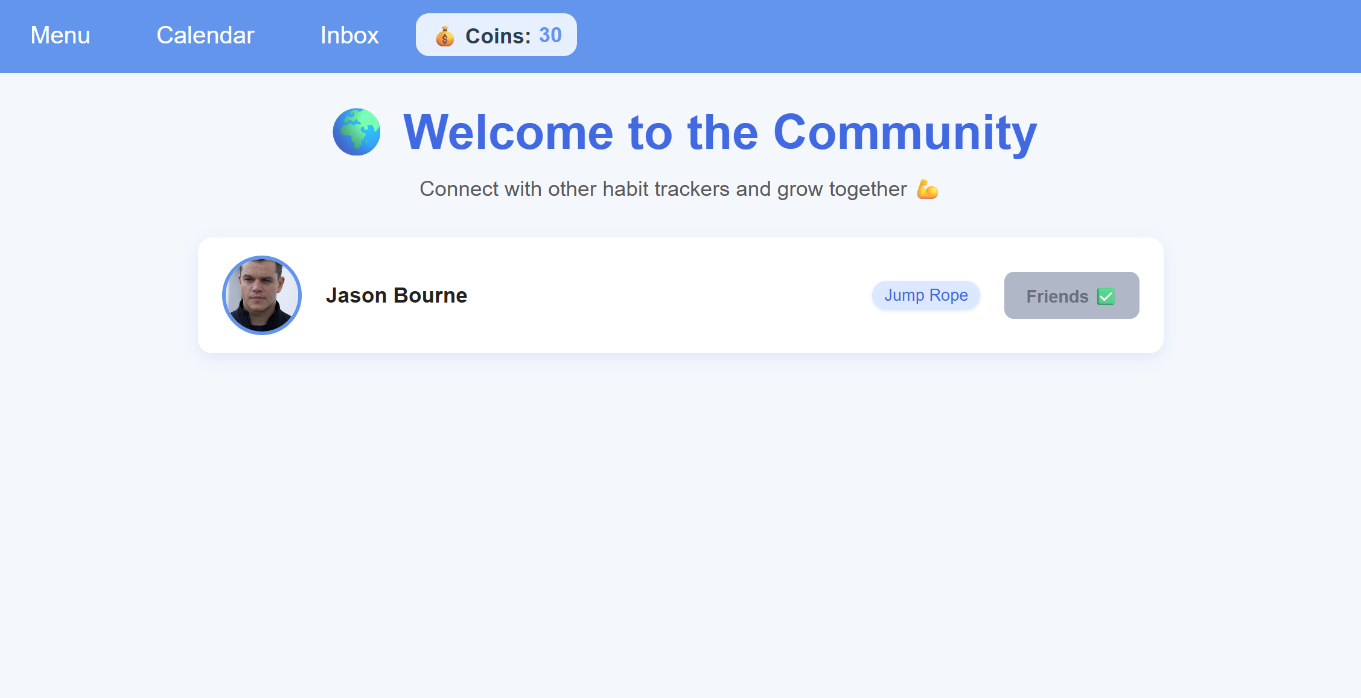 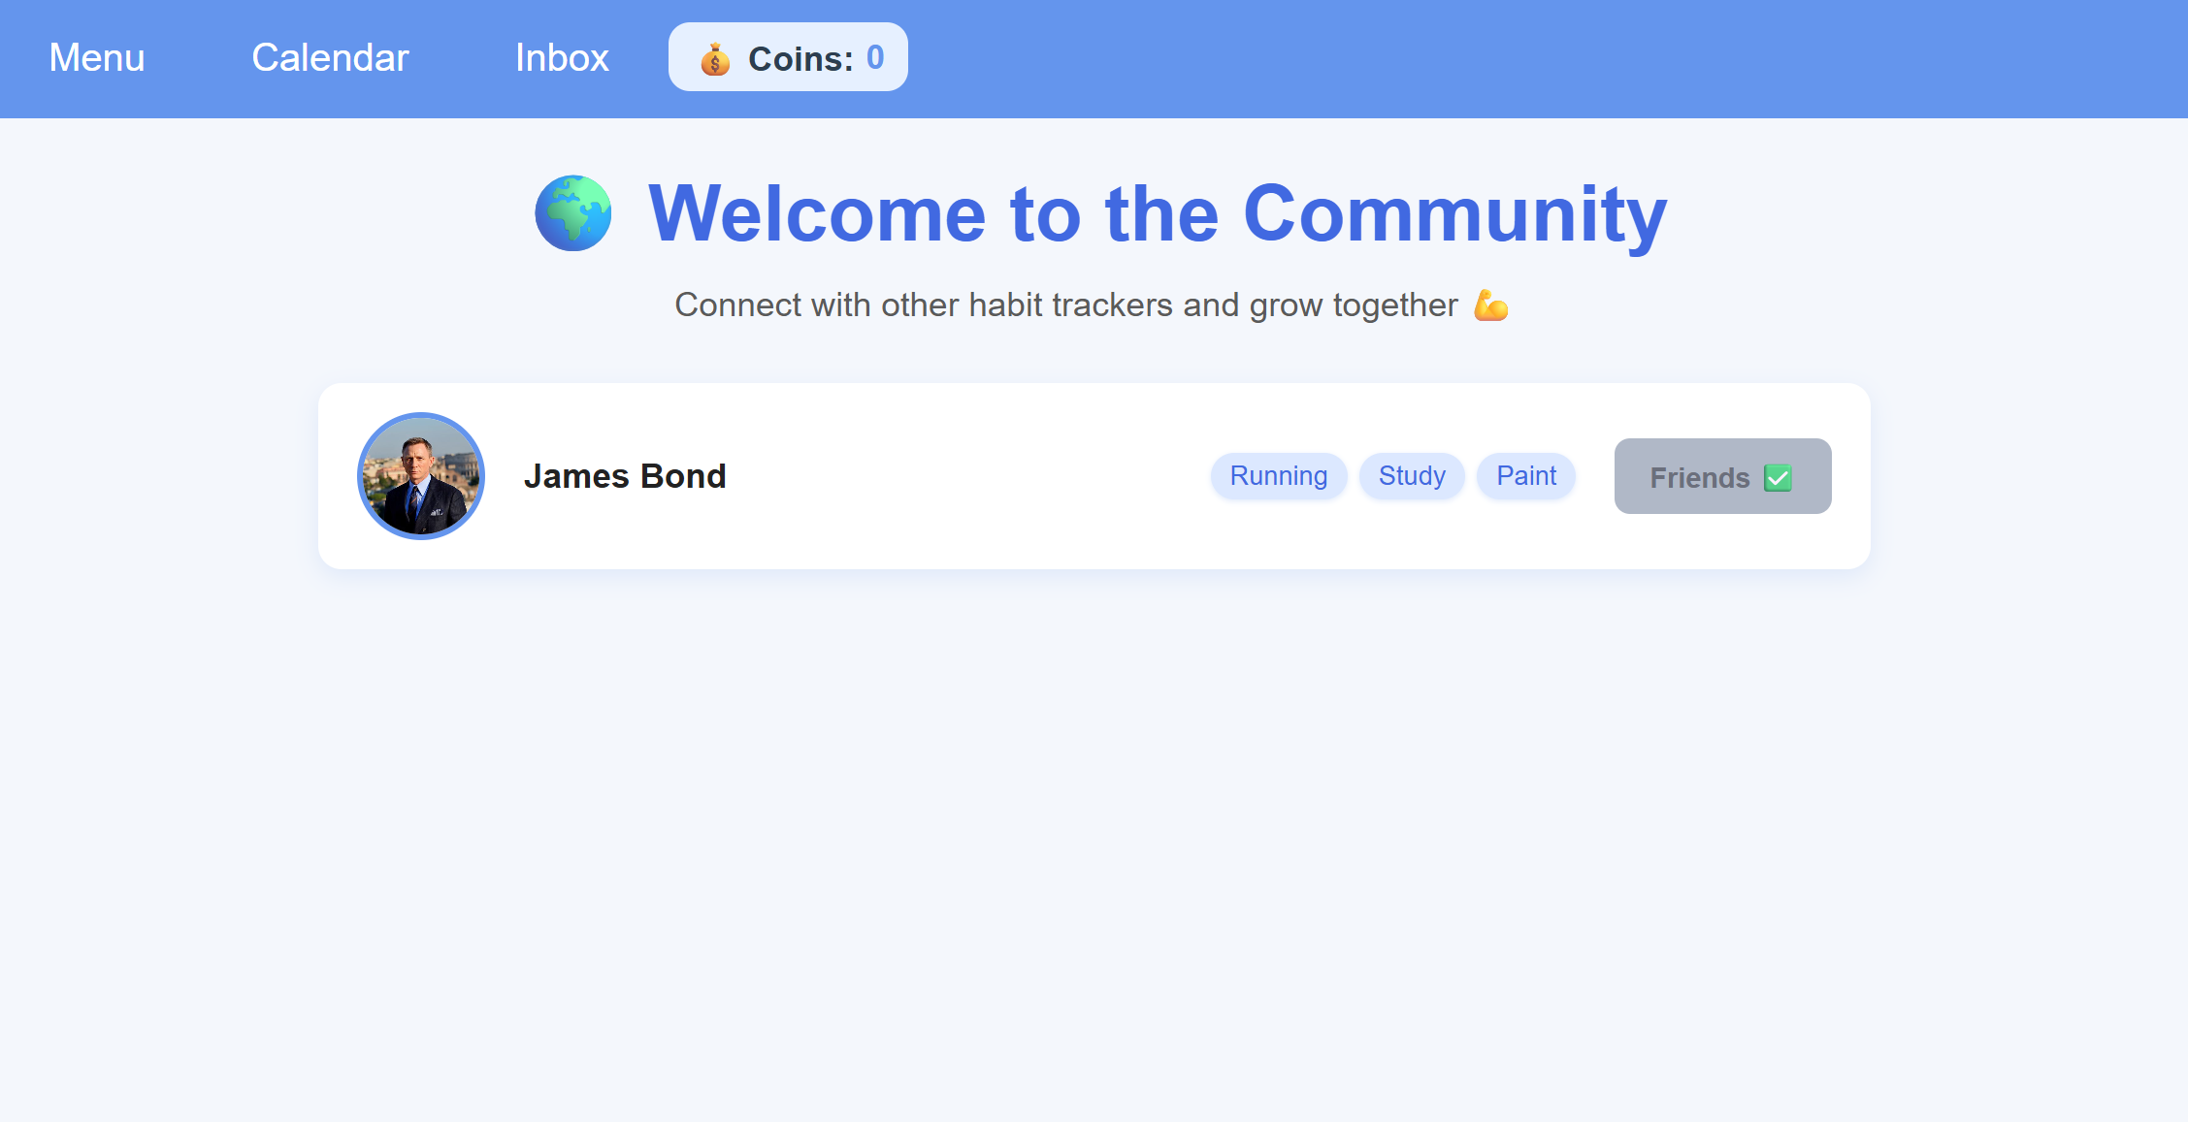

Figure 3.14: Community Page showing all user accounts with their top habits and friendship status. Community page shown from perspective of two different accounts.

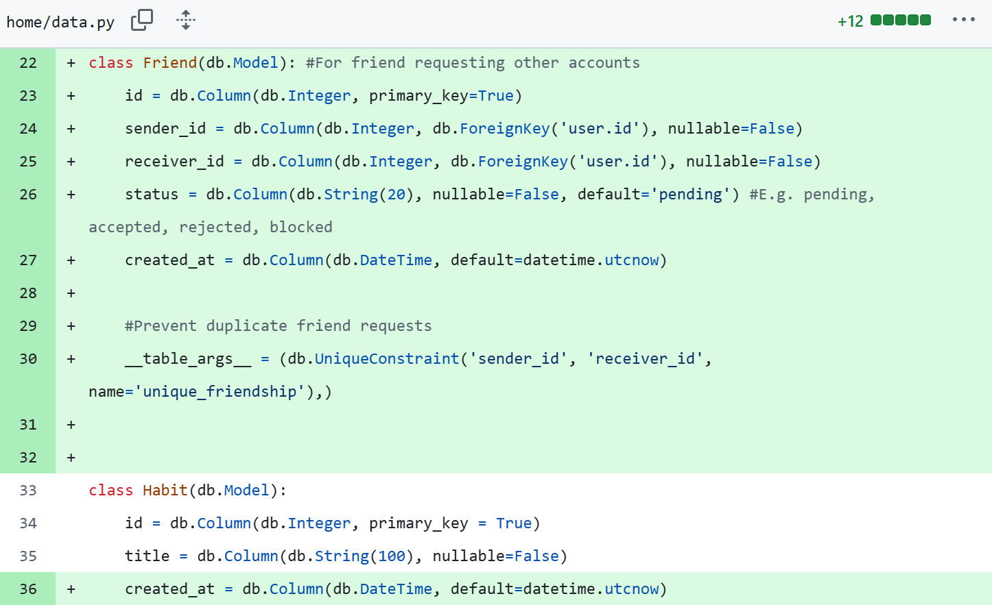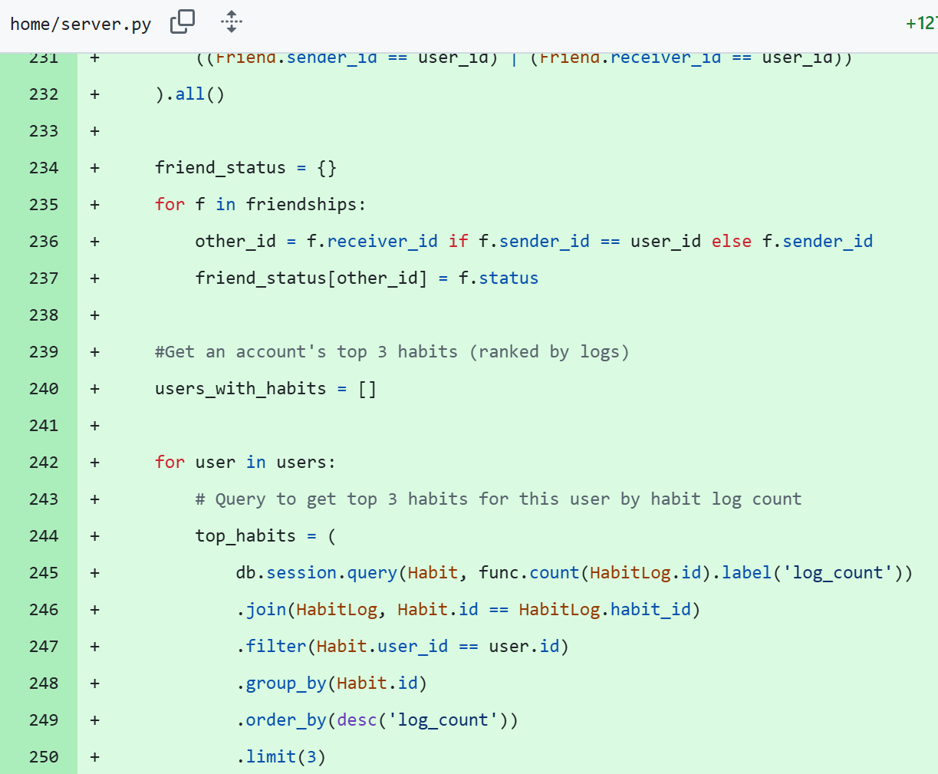

**Evaluation**

Creating the community page required me to add another data table to my database, Friend, which allowed users to send friend requests by holding data like the sender and recipients id and the status of the friend request. After this I created the necessary community html page which would have all accounts, which were the signed in account, fed into the template through the server. Then I could display them in a loop, similar to the ones I’ve used for displaying user accounts on the calendar page (for debugging purposes), items in the shop, and items purchased by the signed in user on their profile. To handle the friend request logic separately from the community page, I created an inbox page where all friend requests were displayed and could be accepted or rejected. This part was much more difficult because I wanted the user have the ability to accept and reject requests which would then update the status of the request on the community page. To do this I used another loop which fed all requests received into the inbox template and displayed every item, giving each request a corresponding accept and reject button. Depending on which button was selected, it would update the status of the request stored in the database. Then when the community page was visited, the logged in user could see the status of their request. For the profile and community page, I also wanted to show the account’s top 3 habits, ranked by how many logs were logged on each habit. This was handled in the server routes by getting the habit object itself and putting it into a dictionary. Then this dictionary was fed into the community and profile templates and styled appropriate to give the top 3 habits a blue glow and background. Continuing in the project, I’d like to start working on either security or advanced features to follow the project notification on Canvas. This was a quite significant milestone, as this marks off all the core features listed in my documentation. Of course, if I feel they are necessary, I can continue to add more but the app now has all of its base functionality.

Date: 18/07/25

**Progress**

|  |  |
| --- | --- |
| Achievements | Stumbling Blocks |
| * Sorting and filtering on habits list * Keyboard navigable website * Password reset feature * Sanitise user inputs * Implemented role-based access feature (admins can delete user accounts) * AI Chatbot helper added * Habit recommendation system added | * Having sorting and filtering logic work properly * Getting habit categories passed into the create habit form |

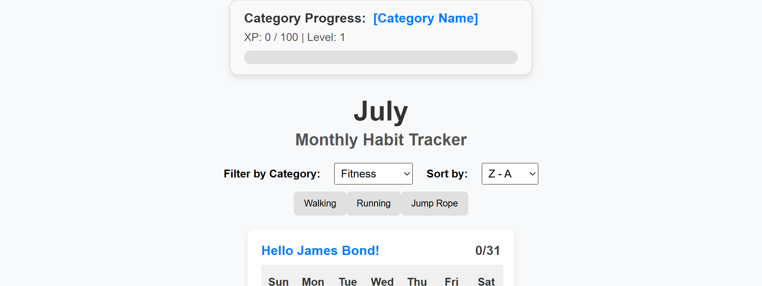

Figure 3.15: Filtering and Sorting options on main calendar

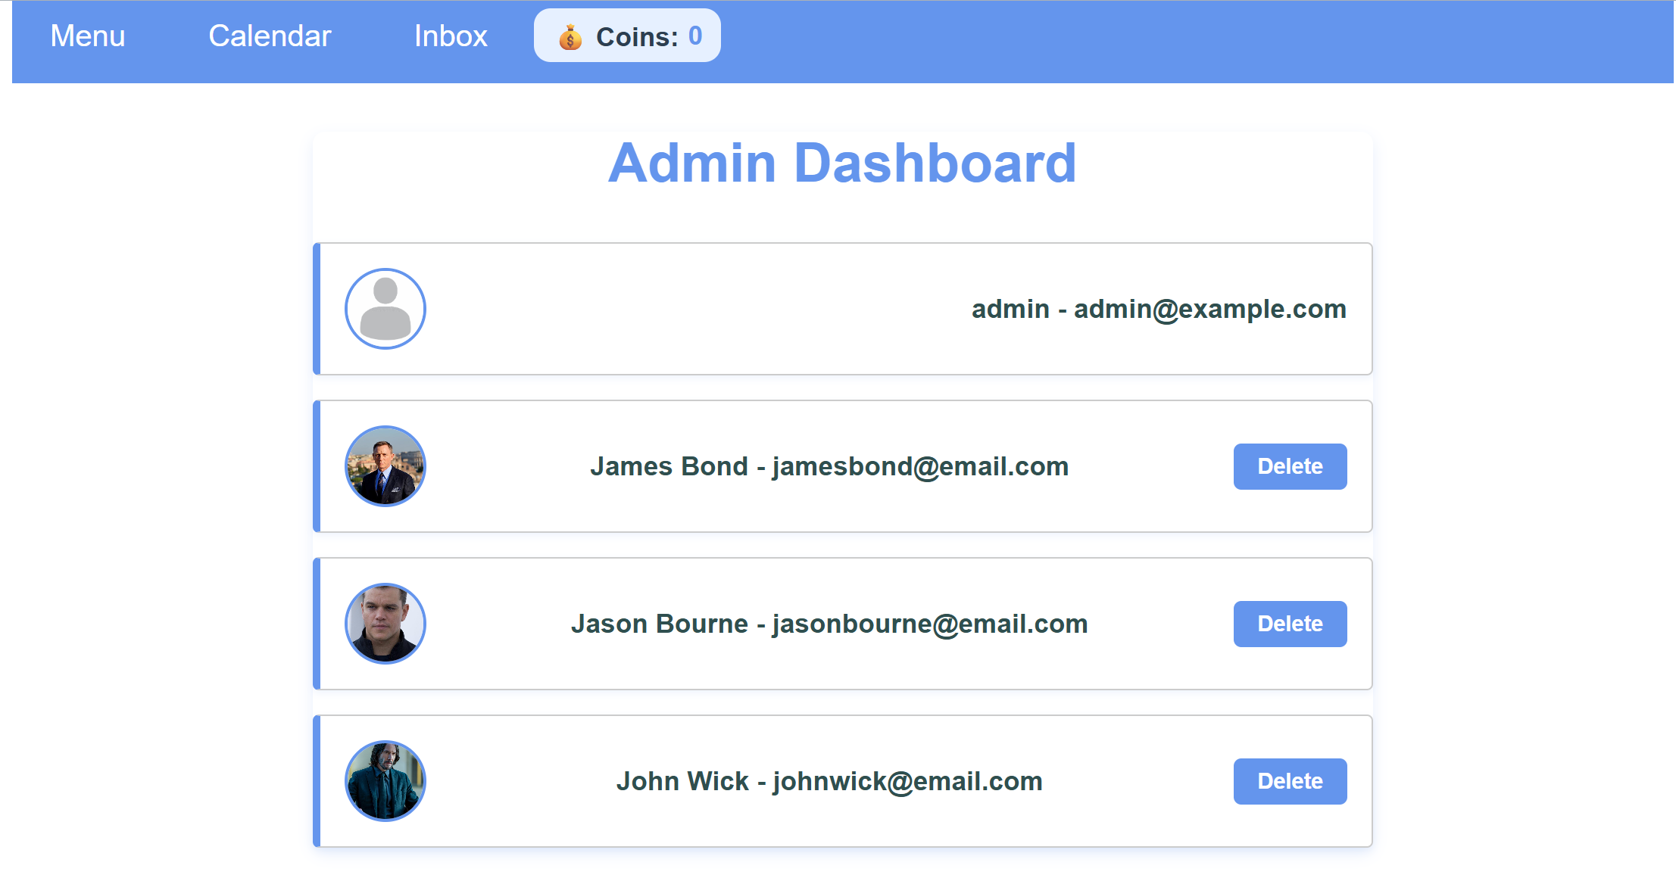

Figure 3.16: Role based access controls where admins have access to admin dashboard and ability to delete user accounts

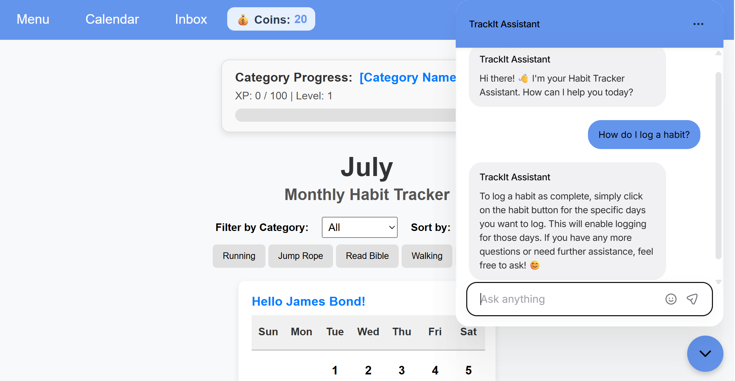

Figure 3.17: AI chatbot assistant located on main calendar answering questions on the app

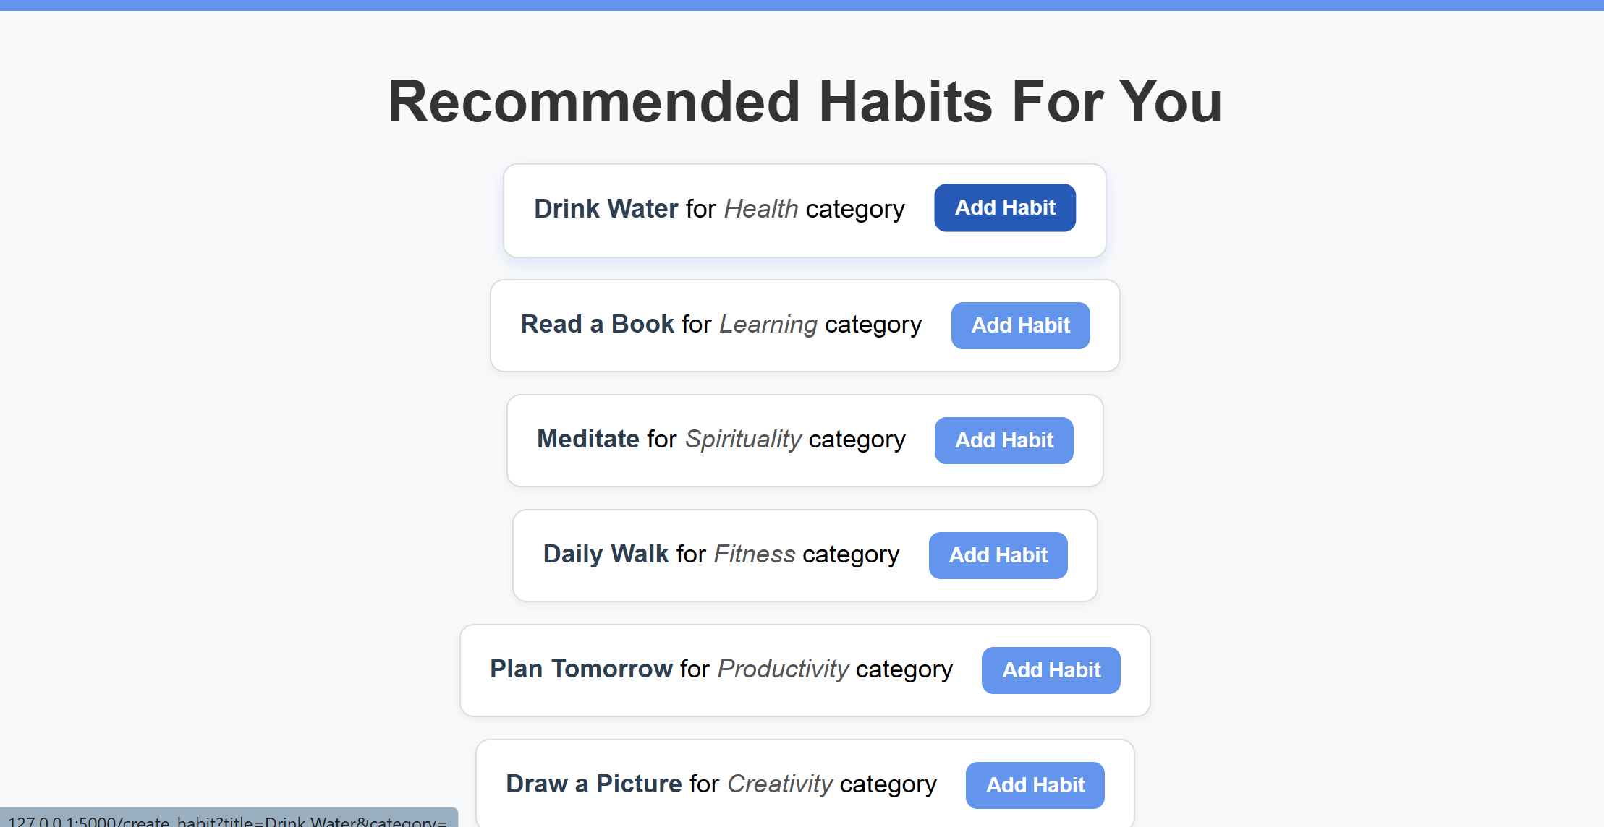

Figure 3.18: Personalisation that recommends habits depending on the user’s most popular categories

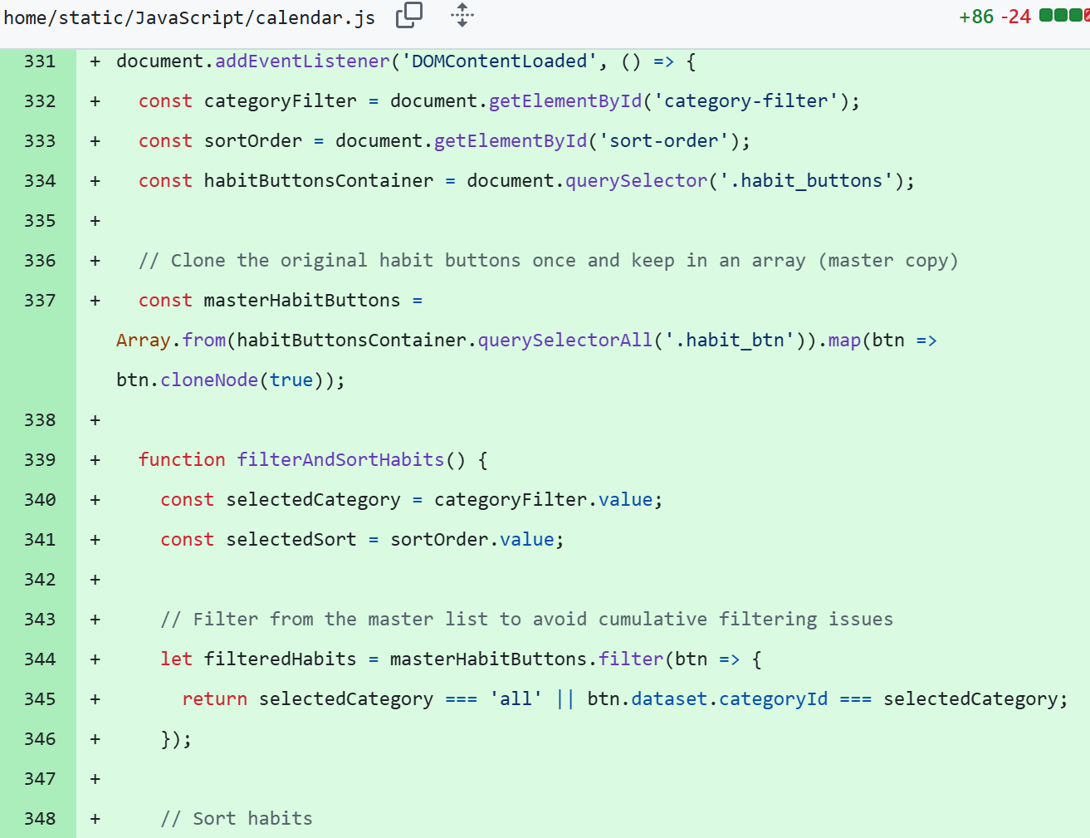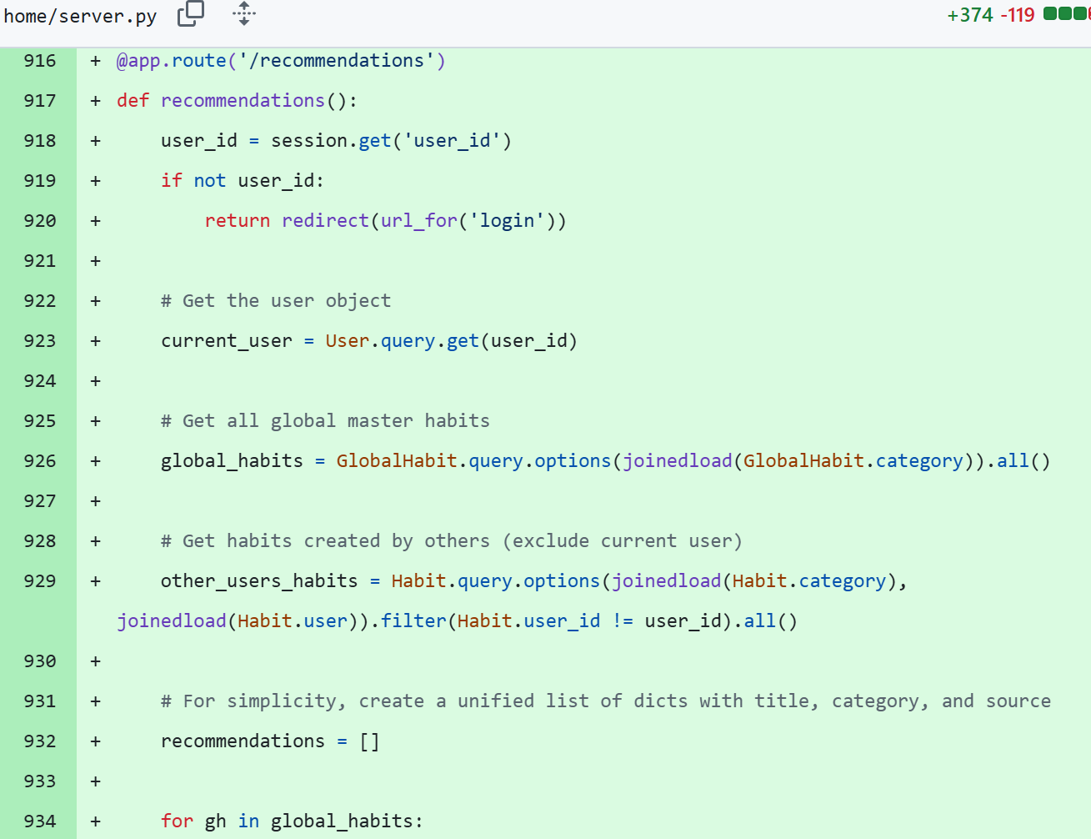

Evaluation

Today I planned to wrap up the prototype by going through the assessment notification and ticking off all the required criteria listed in 3.2. I still had some features to implement but this would be quicker than previous features as these could be added on without affecting the core functionality. I started by creating filtering and sorting options to allow customisation under the UI criteria. I created dropdowns on the calendar template to create the initial list of filtering and sorting options. After this I asked AI to help me code JavaScript functionality. Its solution was to create a master list of the user’s habits and use event listeners to filter the habit list dependent on either a category id or alphanumerical ascending or descending. Then when no filter or sort was selected the master list was displayed on the screen, ensuring all sorts and filters were removed. The outcome of this was the I received complementing JS functionality for my dropdowns of filtering and sorting. I was able to learn the overall logic of how the sorting and filtering works, how they’re removed, and what criteria is used to filter and sort. I then worked on making the app keyboard navigable for accessibility, also under UI criteria. Most of the app was already keyboard navigable as I had been using the correct html variables that, by default, enable keyboard navigation. The only change made was on the dropdown menu’s CSS, adding a ‘focus-within’ variable to allow the keyboard to access the dropdown as well. After this I added a forgotten password and password reset template for the user authentication under the Core Features criteria. This didn’t take too long as I had already created forms before and applied the same logic to this task. I searched through the server file and added ‘escape()’ to all inputs to remove malicious symbols. To create role-based access controls for Data Privacy under Data Security criteria, I added a role attribute to the user model. I then created a decorator in the server and added it to the admin dashboard route so that only accounts that had ‘admin’ role could access the admin dashboard. I then created a simple template for the dashboard, passing in all user accounts through the route. To create an AI chatbot for an advanced feature, I created a free model on Chatbase, customised it to my liking, and then copied in the script from the website onto my calendar template. For the habit recommendation system which would be a second advanced feature, personalisation, I created a template to display all user created habits. I also created another model called GlobalHabits where I could add default habits into the recommendation system, even if they hadn’t been created by another user yet. I then passed both of these into the template through the server and added a create button next to each habit. I linked this button to the create_habite route and passed in the title and category into the route so the user would be redirected to the create habit form and have the details already filled out. The only problem with this was that the category was not passing into the server properly. My debugging output statements said that the category variable being passed in was type ‘None’. I didn’t discover how to fix this problem however, I believe the feature still works well enough. To continue in the project, I’ll start working on “Section 4: Testing and Maintaining”, running acceptance and load tests on my prototype.

Date: 19/07/25

Progress

|  |  |
| --- | --- |
| Achievements | Stumbling Blocks |
| * Conducted acceptance testing and recorded results in documentation scaffold * Performed load testing and recorded results in documentation scaffold * Issued a user survey, collected responses, and recorded results in documentation scaffold | * Finding the best tool for load testing * Identifying helpful question types for the user survey |

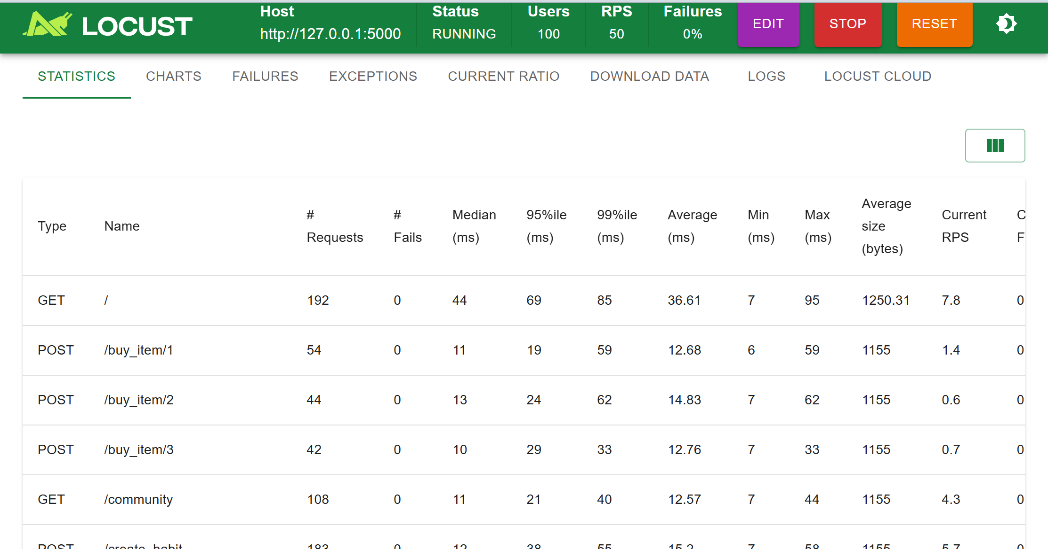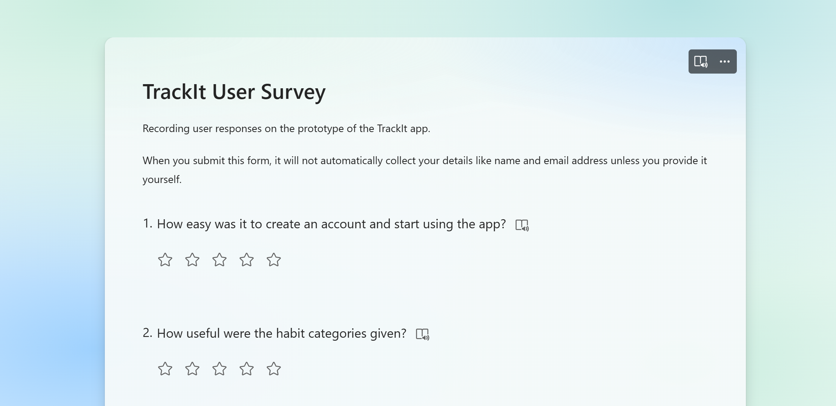

Figure 4.0 & 4.1: Screenshot from locust load test and screenshot of user survey

Evaluation

I first started the testing and maintaining stage by conducting acceptance tests. To do this I created a table of 20 acceptance tests that encompassed all aspects of the site. I then ran each acceptance test on the app, documenting if a test was a pass or fail. For the fails I made sure to include a necessary action I had to perform to fix the app so that if the acceptance test was performed again it would be a pass. Two errors were identified in the app, one with entering incorrect details on login and the other when deleting accounts on the admin dashboard. After I finished documenting the acceptance test, I took the action steps and fixed these two problems by using flashes for errors in my login route and used cascading deletes for my user model. Next was load testing. I didn’t know how to conduct a load test without creating multiple accounts myself manually however, this would be ineffective as I could not run these simultaneously. After researching I discovered that a loading testing tool called locust called be downloaded straight into VS Code. This tool required a python script to run the locusts through the application. I fed my server routes into AI and asked it to generate a python script specifically for locust in VS Code. I then added this script to my project and conducted the tests with this script. I made sure that the resulting script ran through the essential routes in my project (the procedure of which routes is listed in the documentation). I then copied the results into my documentation scaffold and finished the rest of the load testing documentation. Finally, I created a user survey on Microsoft Forms and had my family take a beta test of the app and fill out the survey based on their experience. I collated these responses and created a table of the most common responses to make it easy to identify what actionable steps had to be taken from the survey. The most popular response was to add instructions to my app. Overall, I’m pleased with how all three of these tests turned out as I could complete and document them in a timely manner and received actionable steps to improve my app. To finish the project, I will start working on my video walkthrough.

Date: 21/07/25